

MUFASHE: AI-Powered Legal Assistant for Access to Legal Information in Rwanda

Bachelor of Software Engineering

Nubuhoro Divine

Mission capstone

Supervisor : Thadee Gatera

2026

DECLARATION

This Proposal Project is my original work, unless stated and all external sources have been referenced or cited in my document. This work has not been presented for award of degree or for any similar purpose in any other university

Signature… Date…6 April 2026………
Nubuhoro Divine

CERTIFICATION

The undersigned certifies that he has read and hereby recommended for acceptance of African Leadership University a report entitled ………..

Signature……………………… Date………………………….
Prof/Dr./Mrs./Miss/Mr. Name of the Supervisor
Faculty,
Bachelor of Software Engineering,
ALU

DEDICATION AND ACKNOWLEDGEMENT

This project is dedicated to my family and mentors who supported my academic journey and inspired my interest in using technology to improve access to justice.I would like to express my sincere gratitude to my supervisor, Thadee Gatera, for his guidance, feedback, and support throughout this project.
I also extend my heartfelt thanks to Lawyer Lemezo for the valuable encouragement and support provided during this work.
My special appreciation goes to my dear brother Daniel Nzasabamungu, who encouraged me throughout my academic journey and continuously motivated me to keep moving forward.
I am deeply grateful to my parents, family, friends, and colleagues for their support, encouragement, and valuable insights, which greatly contributed to my progress.
Finally, I would like to thank African Leadership University for providing the academic environment and learning opportunities that supported the development of this project.

Abstract
Access to legal information is an important part of ensuring justice and awareness of rights in society. However, many citizens in Rwanda face challenges understanding legal documents and accessing reliable legal guidance.
The main problem is that legal information is often complex and professional legal services can be expensive or difficult to access. As a result, many people struggle to understand their legal rights or know where to seek help when facing legal issues.
To address this problem, this project developed MUFASHE, an AI-powered legal assistant mobile application that helps users access legal information more easily. The system allows users to ask legal questions and receive answers based on verified legal documents. A document processing pipeline was implemented to convert legal PDF documents into searchable text chunks and embeddings stored in a vector database. When a user submits a question, the system retrieves relevant legal sections and generates responses with references to the original sources. The platform also includes a lawyer directory that allows users to find and book legal professionals when needed.
The results of testing showed that the system was able to successfully retrieve relevant legal information and generate responses based on legal sources. This demonstrates that MUFASHE can help improve legal awareness and support better access to justice in Rwanda.

Table of Contents

1.1 Introduction and Background 13
1.2 Problem statement 13
1.3 Project’s main objective 14
1.3.1List of the specific objectives 14
1.4 Research questions 14
1.5 Project scope 15
1.5.1 Time Scope 15
1.5.2 Coverage of the Study 15
1.5.3 Location and Population 16
1.6 Significance and Justification 17
1.7 Research Budget 19
Table 1: Research Budget 19
1.8 Research Timeline 20
Research Timeline (Gantty chart) 20
2.1 Introduction 21
2.2 Historical Background of the Research Topic 22
2.3 Overview of Existing Systems 23
2.4 Review of Related Work 24
2.4.1 Local Legal Technology Systems 24
2.4.2 International Legal AI Systems 25
2.4.3 Summary of Reviewed Literature 26
2.5 Strengths and Weaknesses of Existing Systems 26
2.6 General Comment and Conclusion 28
3.1 Introduction 30
3.2 Research Design 30
Requirement Analysis 30
System Design 30
Data Preparation and Embedding Generation 31
Vector Search Integration 31
Testing 31
Deployment 31
3.2.1 Dataset and Dataset Description 32
3.3 Functional and Non-Functional Requirements 32
3.3.1 Functional Requirements 33
User Registration and Authentication 33
Legal Question Submission 33
AI-Based Legal Guidance 33
Legal Document Retrieval 33
Lawyer Discovery and Booking 33
Query History 33
Language Switching 34
Dark Mode and Light Mode 34
Font Customization 34
3.3.2 Non-Functional Requirements 34
Usability 34
Performance 34
Security 34
Reliability 34
Scalability 35
Availability 35
Maintainability 35
3.3.3 Proposed Model Diagram 35
3.4 Class Diagram 36
3.5 Entity Relationship Diagram (ERD) 37
3.6 System Architecture 38
Mobile Application 38
Backend API 38
Vector Search and Embedding System 38
Database 38
3.7 Flowchart 39
3.7.2 Use Case Diagram 40
3.7.3 Sequence Diagram for Legal Query Processing 42
3.7.4 Sequence Diagram for Lawyer Booking 42
3.7.5 Database Collections Diagram 43
3.8 Development Tools 45
Chapter Summary 46
4.1 Implementation and Coding 47
4.1.1 Introduction 47
4.1.2 Description of Implementation Tools and Technology 47
4.2 Graphical View of the Project 48
Figure 4.2 User Dashboard 51
Figure 4.3 Consult Screen 53
Figure 4.4 AI Answer / Question Details 53
Figure 4.5 Legal Library 55
Figure 4.6 Lawyers Directory 56
Figure 4.7 Admin Dashboard 59
Figure 4.8 Admin Document Upload 61
4.3 Testing 62
4.3.1 Introduction 62
4.3.2 Objective of testing 62
4.3.3 Unit Testing Outputs 62
4.3.3.1 Overall Test Performance 63
4.3.3.2 Code Coverage Results 63
4.3.3.3 Coverage by System Components 64
4.3.3.4 Testing of Core Functionalities 65
4.3.3.5 Manual API Testing 65
4.3.3.6 Limitations 66
4.3.3.7 Overall Unit testing Evaluation 66
4.3.4 Validation Testing Outputs 66
4.3.5 Integration Testing Outputs 67
4.3.6 Functional and System Testing Results 68
4.3.7 Acceptance Testing Report 68
4.4 Chapter Summary 69
5.1 Introduction 70
5.2 System Performance Results 70
5.3 User Interaction Results 71
5.4 Administrative System Results 71
5.5 User Evaluation Results 72
5.5.1 Age Distribution of Respondents 72
5.5.2 Occupation of Respondents 73
5.5.3 System Usability Evaluation 74
5.5.4 Evaluation of AI Legal Assistance 75
5.5.5 Accuracy of Legal Information 75
5.5.6 Feature Evaluation 76
5.5.7 System Recommendation 77
5.6 Evaluation of System Objectives 78
5.8 Chapter Summary 80
6.1 Conclusion 81
6.2 Recommendations 82
6.3 Limitations of the Study 83
6.4 Suggestions for Future Research 83
References 85

List of Tables
Table 1: Research Budget
Table 2: Strengths and Weaknesses of Existing Systems
Table 3: Development Tools and Their Purposes
Table 4.1: Summary of Unit Testing Results
Table 4.2: Code Coverage Summary
Table 4.3: Coverage by System Layer
Table 4.4: Areas with Lower Coverage

List of Figures

Figure 3.1: Proposed MUFASHE System
Figure 3.2: MUFASHE Class Diagram
Figure 3.3: MUFASHE Entity Relationship Diagram (ERD)
Figure 3.4: MUFASHE System Architecture Diagram
Figure 3.5: MUFASHE Legal Query Processing Flowchart
Figure 3.6: MUFASHE Use Case Diagram
Figure 3.7: Sequence Diagram for MUFASHE Legal Query Processing
Figure 3.8: Sequence Diagram for MUFASHE Lawyer Booking
Figure 3.9: MUFASHE Database Collections Diagram
Figure 4.1: Welcome Page
Figure 4.2: User Dashboard
Figure 4.3: Consult Screen
Figure 4.4: AI Answer / Question Details
Figure 4.5: Legal Library
Figure 4.6: Lawyers Directory
Figure 4.7: Admin Dashboard
Figure 4.8: Admin Document Upload

List of Acronyms and Abbreviations

Acronym | Meaning
AI | Artificial Intelligence
NLP | Natural Language Processing
ICT | Information and Communication Technology
NCNM | National Case Management System
IECMS | Integrated Electronic Case Management System
LAF | Legal Aid Forum
UCD | User-Centered Design
AWS | Amazon Web Services
DB | Database
API | Application Programming Interface
OECD | Organisation for Economic Co-operation and Development
UNDP | United Nations Development Programme
R&D | Research and Development
UC | Use Case
PK | Primary Key
FK | Foreign Key
UML | Unified Modeling Language
ERD | Entity Relationship Diagram
ML | Machine Learning
AI/ML | Artificial Intelligence and Machine Learning
ISO | International Organization for Standardization

Relationship Notations
Notation | Meaning
1 — * | One-to-many relationship
1 — 1 | One-to-one relationship
* — * | Many-to-many relationship

CHAPTER ONE: INTRODUCTION

1.1 Introduction and Background
Access to legal information is essential for citizens to understand their rights and responsibilities. However, legal systems often rely on complex language and lengthy documents that are difficult for the general public to interpret. In Rwanda, many individuals lack easy access to reliable legal information and legal professionals. As a result, people may make decisions without fully understanding the legal implications.
Advances in artificial intelligence and natural language processing have created opportunities to improve access to legal knowledge. AI-based assistants can analyze legal documents and provide users with simplified explanations and relevant references.
To address these challenges, this project developed MUFASHE, an AI-powered mobile legal assistant that helps users ask legal questions and receive simplified explanations based on verified legal documents. The platform processes legal texts using natural language processing and vector search techniques to retrieve relevant laws and generate understandable responses. The system also includes a lawyer directory that allows users to connect with legal professionals when needed.

1.2 Problem statement
Many citizens in Rwanda face challenges when trying to access legal information or understand legal documents. Legal texts are often written in technical language that is difficult for non-professionals to interpret. Additionally, consulting lawyers can be expensive and inaccessible for many individuals.
As a result, people may lack awareness of their rights, leading to legal misunderstandings and poor decision-making. There is therefore a need for a system that can provide accessible, reliable, and understandable legal information to the public.

1.3 Project’s main objective
To develop an AI-powered mobile application that improves access to legal information and legal services in Rwanda.

1.3.1List of the specific objectives
- To design and develop a mobile AI-based system that enables users to submit legal questions and retrieve relevant legal information from verified legal documents.
- To implement a legal document processing pipeline that converts legal texts into structured data and searchable embeddings to support accurate AI-assisted legal information retrieval.
- To provide simplified explanations of legal concepts and possible solutions that can be easily understood by non-lawyers and users with different education levels.
- To evaluate the usability and effectiveness of the MUFASHE platform through user testing and system performance analysis in order to assess its ability to retrieve relevant legal information and provide helpful responses.

1.4 Research questions
- How can a mobile AI-based system be designed to analyze users’ legal questions and retrieve relevant legal information from verified legal documents?
- How can legal documents be processed and transformed into searchable embeddings to support accurate AI-assisted legal information retrieval?
- How can legal concepts and possible legal solutions be explained in a simplified way that is understandable to non-lawyers?
- How usable and effective is the MUFASHE platform in helping users retrieve legal information and understand legal issues through user testing and system performance evaluation?

1.5 Project scope

1.5.1 Time Scope
The study was conducted over a period of approximately three months. During this time, the MUFASHE platform was designed, developed, implemented, and evaluated. The project involved several stages, including system analysis, system design, software development, integration of artificial intelligence components, system testing, and evaluation of system performance and usability. The final phase of the study focused on validating the functionality of the platform and documenting the outcomes of the implemented solution.

1.5.2 Coverage of the Study
This study focused on the design, development, and evaluation of MUFASHE, an AI-driven mobile application developed to improve legal awareness and access to justice for Rwandan citizens who are literate and have access to digital tools and internet connectivity. The platform was designed to allow users to submit legal questions through a mobile interface and receive simplified explanations of relevant laws based on information retrieved from legal documents.
The implemented system includes several core functionalities. Users are able to register and log into the application, submit legal questions, and receive AI-assisted responses based on relevant legal sources. The platform also provides access to a legal document library containing legal information used by the system to generate responses. In addition, a lawyer directory feature allows users to view profiles of available legal professionals and request consultations when professional assistance is required.
To support these capabilities, the system processes legal documents using natural language processing and vector-based search techniques. Legal texts are converted into structured and searchable representations that enable the system to retrieve relevant legal information when a user submits a question. This retrieval-based approach helps improve the relevance and reliability of the legal explanations generated by the platform.
The target population for the system includes individuals who are able to read and write, as they can interact with the application’s text-based interface to input legal concerns and interpret the explanations provided by the system. According to data from the National Institute of Statistics of Rwanda, approximately 78.8 % of the population aged 15 years and above are literate, indicating a large potential user base capable of engaging with written digital content (Statistics Gov Rwanda, 2025).
In terms of digital access, Rwanda has experienced significant growth in mobile and internet connectivity. By the end of 2025, the country had approximately 5.01 million internet users, representing about 34.2 % of the population, and about 13.0 million active mobile connections, equivalent to roughly 88.7 % of the population (DataReportal, 2026). These trends indicate that a substantial portion of Rwandans can potentially access a mobile-based system such as MUFASHE through widely available mobile devices.

1.5.3 Location and Population
The MUFASHE mobile application project was conducted within the Republic of Rwanda, a country in East Africa that has increasingly prioritized digital transformation and technology-driven development. Rwanda’s estimated national population reached approximately 14.7 million people in 2025, with a median age of about 19.9 years, reflecting a predominantly young population that is increasingly engaged with digital technologies (DataReportal, 2026).
Administratively, Rwanda is divided into provinces, districts, sectors, cells, and villages, with the City of Kigali serving as the capital and most urbanized region. Kigali hosts more than 1.7 million residents and functions as a central hub for digital services, innovation, and technology adoption (Statistics Gov Rwanda, 2025). Due to stronger digital infrastructure and connectivity, urban areas such as Kigali often demonstrate higher adoption rates of digital platforms compared to rural regions.
Population distribution in Rwanda shows that approximately 18.4 % of the population lives in urban areas, while about 81.6 % reside in rural areas (DataReportal, 2026). This distribution is important when considering the potential reach of digital platforms such as MUFASHE. Although urban populations generally have greater access to stable internet services and digital tools, rural populations may experience limitations related to connectivity, infrastructure, and affordability of internet services.
Literacy levels also influence the potential user base for the system. Recent census data indicate that approximately 78.8 % of Rwandans aged 15 years and above are literate, with literacy rates reaching about 89.8 % in urban areas and 74.2 % in rural areas (Statistics Gov Rwanda, 2023). Since MUFASHE relies on text-based interaction for submitting questions and presenting legal explanations, literacy is an important factor enabling effective use of the platform.
Regarding digital penetration, approximately 34.2 % of the population were active internet users by late 2025, while mobile connectivity reached approximately 88.7 % of the population, demonstrating that mobile devices represent the primary channel through which many citizens access internet-based services (DataReportal, 2026). However, internet usage remains uneven across geographic areas, with rural regions experiencing lower connectivity levels due to infrastructure limitations and affordability challenges (AllAfrica, 2025).
Considering these demographic and technological conditions, the MUFASHE platform primarily targets literate Rwandan citizens who possess mobile devices and have access to internet connectivity. The system is designed to support individuals seeking simplified explanations of legal concepts and guidance for everyday legal issues, thereby helping bridge the gap between legal knowledge and access to justice.

1.6 Significance and Justification
Access to justice remains a major challenge for many ordinary citizens in Rwanda. Although legal information is available through official platforms and legal institutions, many individuals still struggle to understand legal procedures, interpret legal texts, and identify the appropriate actions to take when facing legal issues. Legal language is often complex and technical, making it difficult for non-professionals to interpret laws without assistance. Additionally, professional legal services are often expensive and not easily accessible to all members of the population.
Existing digital legal platforms in Rwanda, such as Amategeko.gov.rw and RwandaLII, provide public access to laws and judicial decisions. While these platforms improve transparency and availability of legal information, they mainly provide raw legal documents without simplified explanations. As a result, citizens must still interpret the legal content on their own, which limits the practical usefulness of these platforms for individuals without legal training.
This study is significant because it proposes and implements MUFASHE, an AI-driven mobile platform designed to make legal information more accessible and understandable to ordinary citizens. The system uses artificial intelligence techniques to process legal documents and generate simplified explanations of legal concepts based on user questions. By translating complex legal information into more understandable language, the platform helps users better understand their legal rights and possible options for resolving legal issues.
The platform also contributes to improving access to justice by providing users with guidance before they seek professional legal assistance. In addition to the AI legal explanation feature, the system includes a lawyer directory, which enables users to identify and connect with legal professionals when necessary. This approach helps bridge the gap between citizens and the legal system by combining digital legal guidance with access to human legal expertise.
From a technological perspective, this study demonstrates the potential of artificial intelligence, natural language processing, and mobile technologies to support justice systems and public legal awareness. The implementation of MUFASHE shows how modern information technologies can be used to develop user-centered solutions that address real societal challenges, particularly in contexts where legal knowledge and access to professional legal services remain limited.
Furthermore, the study contributes to academic and practical discussions on legal technology (LegalTech) in Rwanda by exploring how AI-based systems can complement existing legal information platforms. The findings of this research may inform future development of digital justice tools that focus on improving legal literacy, accessibility, and citizen engagement with legal institutions.
Overall, the study is justified by the need to develop innovative technological solutions that help citizens better understand their rights, make informed decisions, and interact more confidently with the justice system. By improving access to legal information through a mobile AI platform, MUFASHE contributes to strengthening legal awareness and supporting more inclusive access to justice in Rwanda.

1.7 Research Budget
The development of the MUFASHE project was completed mainly using free and open-access tools. Most of the software technologies and development platforms used in the study, such as React Native, Expo, Node.js, Express, MongoDB Atlas free tier, and Render free tier, did not require direct financial payment during the implementation phase. However, some costs were still incurred during the research process, especially for transport and field engagement activities such as meeting lawyers, consulting potential users, and moving to and from school for project-related work.

Table 1: Research Budget
Item | Description | Unit Cost (USD) | Total Cost (USD)
Field Research Transport | Transport costs for meeting lawyers, potential users, and attending project-related movements to school and other locations | 60 | 60
Printing and Documentation | Printing drafts, notes, and related research materials | 15 | 15
Internet/Data Bundles | Internet access for development, testing, communication, and research activities | 75 | 75
 |  | GRAND TOTAL | 150

1.8 Research Timeline
The development of the MUFASHE platform was completed in approximately three months. The project moved through five main phases: problem identification and literature review, system analysis and design, system implementation, testing and evaluation, and final documentation. Each phase contributed to the successful development of the AI-driven legal assistance platform.

Research Timeline (Gantty chart)

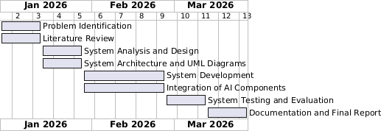

CHAPTER TWO: LITERATURE REVIEW

2.1 Introduction
Access to justice refers to the ability of individuals to seek and obtain remedies through formal or informal justice institutions, and it is widely recognized as a central component of the rule of law and inclusive development. Research has shown that digital technologies, including artificial intelligence (AI), have the potential to strengthen justice systems by improving efficiency, transparency, and responsiveness to citizens’ needs (Organisation for Economic Co-operation and Development [OECD], 2025). Although digital justice tools such as electronic case management systems have improved administrative processes, many individuals still face difficulties in understanding their legal rights and navigating legal procedures, particularly in contexts where legal literacy remains limited (Legal Aid Forum, 2023). In Rwanda, digital platforms such as the Integrated Electronic Case Management System (IECMS) and online legal information portals have expanded access to justice information and improved institutional efficiency; however, important gaps remain in tools that provide clear, intuitive, and user-friendly legal guidance for ordinary citizens (Ministry of Justice, 2024). At the same time, emerging AI-based legal systems are increasingly being considered as possible solutions to these gaps because they can support legal research, case analysis, and interactive legal information delivery (RwandaLII, 2025).
Nevertheless, the use of AI in justice systems also raises unresolved ethical and implementation concerns, including issues of fairness, accountability, transparency, privacy, digital literacy, infrastructure limitations, and the risk of over-reliance on automated systems (UNESCO, 2021; OECD, 2025). This chapter therefore reviews local and international literature on digital justice systems and AI-based legal technologies, with particular attention to their strengths, weaknesses, ethical implications, and implementation challenges, in order to identify the research gap that informed the development of the MUFASHE platform in Rwanda.

2.2 Historical Background of the Research Topic
The integration of software into justice systems historically began with efforts to digitize legal information and improve the management of legal records. Traditionally, legal systems relied heavily on printed law books, official gazettes, and manual court records, which made legal information difficult to search and access. With the advancement of information technology, many countries introduced searchable online legal databases as foundational tools for improving transparency and public access to legal texts (Palfrey, 2013). These digital platforms allowed legal professionals, researchers, and citizens to retrieve legal documents more efficiently and represented an important step toward modernizing justice systems.
In Rwanda, similar initiatives have emerged to ensure that citizens, legal practitioners, and researchers can access laws and case law conveniently through digital platforms. One landmark development in Rwanda’s legal information ecosystem is the Amategeko.gov.rw portal, launched on 25 November 2022 by the Rwanda Law Reform Commission to make legal texts, laws in force, and selected case law freely available online (KT Press, 2022). This national legal portal allows users to browse Rwanda’s legal materials, promoting transparency and reducing barriers related to physical access to paper documents that were previously scattered across various institutions. By centralizing legal information that was once available only in official gazettes or archives, the portal contributes to improving public awareness of legal norms and judicial decisions.
In addition to the national portal, the Rwanda Legal Information Institute (RwandaLII) provides free access to a broad collection of Rwandan legislation, regulations, and judicial decisions, contributing to open legal knowledge and supporting research needs for both legal professionals and the public (RwandaLII, 2025). RwandaLII forms part of the global Free Access to Law Movement, which advocates for open and online access to legal information as a means of strengthening the rule of law and democratic governance.
Despite these digital resources reducing barriers to retrieving legal texts, research and practitioner reports indicate that many ordinary citizens still face significant challenges in interpreting and applying legal information to real-world problems. In Rwanda, limited legal literacy and the technical complexity of legal language mean that access to legal texts alone does not necessarily translate into meaningful access to justice for most people (Legal Aid Forum, 2023). These limitations highlight the need for systems that go beyond simple access to documents and instead provide interactive and understandable legal guidance.
Globally, legal technology has continued to evolve beyond static legal databases toward more interactive and user-centered solutions. For example, mobile-based legal assistance platforms such as DoNotPay and Rocket Lawyer have demonstrated how digital tools can provide users with simplified legal information, automated document support, and guided legal assistance through mobile applications. These platforms illustrate the shift from document-centered legal systems toward more accessible, technology-driven legal services that aim to assist users directly in understanding and addressing legal issues.
Overall, Rwanda’s historical development of legal information systems, from digitizing laws and judgments to launching centralized online portals such as Amategeko.gov.rw and RwandaLII, reflects a broader global trend toward using information technology in justice systems. However, both local legal portals and international legal technology platforms reveal persistent gaps in citizen-centered interpretive support. These gaps highlight the need for innovative digital tools capable of providing simplified, interactive, and accessible legal guidance, which motivates the current research into AI-driven and user-friendly legal guidance platforms such as MUFASHE.

2.3 Overview of Existing Systems
Several digital platforms have been developed globally to support legal information access, legal research, and justice administration. These systems range from online legal databases and court management platforms to artificial intelligence (AI) tools designed to assist legal professionals. In Rwanda, digital justice initiatives such as the Integrated Electronic Case Management System (IECMS), RwandaLII, and Amategeko.gov.rw have improved transparency and accessibility of legal documents. However, these systems mainly focus on document access and administrative processes rather than providing interpretive legal guidance for citizens.
Internationally, legal technology has advanced further with the development of AI-based legal research platforms and automated legal assistance tools. Systems such as Lexis+ AI, Westlaw Edge, and CoCounsel support legal professionals in conducting research, analyzing legal documents, and drafting legal materials. Additionally, consumer-facing legal applications such as DoNotPay and Rocket Lawyer provide simplified legal services through web and mobile platforms. Despite these developments, many existing systems remain designed either for professional legal users or for limited automated tasks rather than offering comprehensive citizen-centered legal guidance.

2.4 Review of Related Work

2.4.1 Local Legal Technology Systems
In Rwanda, digital justice systems have primarily focused on improving administrative efficiency and access to legal information rather than providing personalized legal guidance for citizens. One important example is the Integrated Electronic Case Management System (IECMS), which supports electronic case filing, case tracking, and court workflow management across the justice sector. The system has significantly improved the efficiency and transparency of court processes by enabling better monitoring of cases and facilitating coordination among justice institutions (KT Press, 2024). However, IECMS mainly serves legal professionals and court administrators. It does not provide simplified explanations of legal procedures or interpretive support for ordinary citizens, which limits its contribution to meaningful access to justice.
Legal information portals such as RwandaLII and Amategeko.gov.rw also play an important role in Rwanda’s digital justice ecosystem. These platforms provide centralized online access to legislation, judicial decisions, and other legal documents, thereby improving transparency and enabling the public to retrieve legal information more easily (RwandaLII, 2025; Nuwamanya, 2022). While these platforms enhance the availability of legal information, the content is largely presented in formal legal language. As a result, citizens are often required to interpret complex legal terminology independently, which remains a significant barrier for individuals with limited legal literacy (Legal Aid Forum, 2023).
Community-based legal aid initiatives further support access to justice in Rwanda. Organizations such as the Legal Aid Forum (LAF) deploy paralegals and conduct legal awareness programs to help citizens understand their rights and access legal services. Although these initiatives have improved legal awareness and community support, they rely heavily on in-person service delivery and manual processes. Consequently, their ability to provide tailored, case-specific assistance to large numbers of citizens remains limited, particularly in remote areas (Legal Aid Forum, 2024).
Overall, while Rwanda’s local legal technology systems have improved access to legal information and administrative efficiency within the justice sector, they do not yet provide interactive, user-friendly legal guidance that helps citizens interpret laws and navigate legal procedures independently.

2.4.2 International Legal AI Systems
Internationally, artificial intelligence technologies have increasingly been integrated into the legal sector to improve legal research, document analysis, and case management. Professional legal AI systems such as Lexis+ AI, Westlaw Edge, and CoCounsel assist lawyers in analyzing legal documents, identifying precedents, and automating parts of the legal research process (OECD, 2025). These systems significantly improve efficiency when dealing with large volumes of legal data. However, they are primarily designed for legal professionals and require legal expertise to interpret outputs correctly.
In addition to professional research tools, several AI-based platforms have been developed to provide legal assistance directly to the public. For example, DoNotPay and Rocket Lawyer are digital legal service platforms accessible through web and mobile applications. These systems provide automated legal document generation, guided legal assistance, and simplified explanations of certain legal processes. While such platforms demonstrate the potential of technology to expand access to legal services, they also present limitations. Many of these tools operate within specific legal jurisdictions and may not be easily adaptable to other legal systems. Furthermore, concerns have been raised regarding the reliability and accountability of automated legal advice when AI-generated outputs are not supervised by legal professionals.
Research on AI in justice systems also highlights important ethical and practical challenges. These include concerns related to data privacy, algorithmic bias, transparency of AI decision-making, and the risk of over-reliance on automated systems (OECD, 2025; UNESCO, 2025). Additionally, implementation barriers such as limited digital infrastructure, uneven digital literacy levels, and institutional resistance may slow the adoption of AI technologies in justice systems, particularly in developing countries.
Although international AI-based legal technologies demonstrate strong technical potential, most existing applications focus either on professional legal research or narrow automated legal tasks. Few systems provide comprehensive, citizen-centered legal guidance that is understandable without legal training.

2.4.3 Summary of Reviewed Literature
The reviewed literature demonstrates that both local and international legal technology systems have improved access to legal information and enhanced administrative efficiency within justice systems. In Rwanda, platforms such as IECMS, RwandaLII, and Amategeko.gov.rw have strengthened transparency and document accessibility, while community-based legal aid initiatives have contributed to increasing legal awareness among citizens. However, these systems primarily provide access to legal documents rather than interpretive support that helps citizens understand and apply legal rules to their individual situations.
Internationally, AI-based legal systems such as Lexis+ AI, CoCounsel, and other emerging legal technologies demonstrate the potential of artificial intelligence to analyze large legal datasets and support legal decision-making. At the same time, citizen-oriented legal apps such as DoNotPay and Rocket Lawyer illustrate the growing role of mobile and AI technologies in expanding legal service accessibility. Despite these advancements, most systems remain either professional-oriented or limited in scope, and concerns about ethical governance, reliability, and jurisdictional applicability continue to be raised.
Overall, the literature reveals a clear gap. Existing systems either provide access to legal documents without interpretive support or offer AI-based tools designed primarily for legal professionals. There is currently no widely available system that combines AI-driven legal analysis with simplified explanations and actionable legal guidance tailored specifically for non-lawyers within the Rwandan legal context. Addressing this gap forms the foundation for the development of the MUFASHE platform.

2.5 Strengths and Weaknesses of Existing Systems
System / Platform | Strengths (What It Does Well) | Weaknesses (Where It Falls Short)
IECMS (Integrated Electronic Case Management System) | Makes court case filing and tracking digital and faster for courts. | Does not help citizens understand legal rights or next steps; primarily organizes court processes (KT Press, 2024).
Amategeko.gov.rw & RwandaLII | Provide free online access to laws and judicial decisions in Rwanda. | Provide raw legal texts that are difficult for ordinary users to interpret (RwandaLII, 2024).
Community Legal Aid (LAF) | Provides legal education and awareness through paralegals and community outreach programs. | Relies on in-person services and lacks digital automation, limiting scalability (Legal Aid Forum, 2024).
IST Legal AI Prototype (Rwanda) | Demonstrates potential use of AI to assist legal analysis and decision support. | Still experimental and primarily oriented toward legal professionals (Africa Press, 2024).
LegalWebAgent | Automates complex legal tasks and multi-step legal processes using AI reasoning. | Requires technical expertise and is not adapted to local legal contexts (Tan & Benyekhlef, 2025).
CoCounsel / Lexis+ AI | Supports lawyers with legal research, document drafting, and case analysis. | Designed for professionals and may produce confusing outputs for non-lawyers (Magesh et al., 2024).
Lawbots (generic) | Automate simple legal assistance tasks such as answering basic legal questions online. | Limited to narrow tasks and cannot provide detailed case-specific guidance.
PainWorth | Helps estimate potential personal injury claim values and legal options. | Limited to specific legal domains such as injury claims (PainWorth, n.d.).
Doctrine (AI legal search engine) | Collects and indexes legal cases for efficient research. | Designed for professional legal research rather than public guidance.
JustCite | Facilitates efficient legal research by connecting related cases and references. | Focused on research rather than practical legal assistance for citizens.
DoNotPay (Mobile Legal Assistance App) | Provides automated legal assistance for common consumer-related issues through web and mobile platforms. | Limited jurisdictional coverage and concerns about reliability of automated advice.
Rocket Lawyer (Mobile Legal Services App) | Offers legal document templates and access to legal services through mobile and web platforms. | Subscription-based and not tailored to Rwandan legal systems.
Overall, existing systems strengthen legal information access and professional efficiency. However, they do not provide interactive, case-specific, and simplified legal guidance that everyday citizens require to understand their rights and navigate legal issues independently.

2.5.2 Benchmarking
Benchmarking in MUFASHE evaluates system performance using measurable indicators. The system processes real legal documents and generates responses in approximately 128 seconds. Retrieval relevance is measured using similarity scores, where values above 0.80 out of 1.00 indicate strong matches between user queries and legal sources.
In addition, benchmarking considers answer clarity, usefulness, and system reliability, with most queries returning meaningful, source-supported responses. However, results show that high similarity scores do not always guarantee perfect contextual accuracy, highlighting the need for further improvement in domain-specific retrieval.
Overall, benchmarking demonstrates that MUFASHE provides relevant and reliable legal guidance, while identifying areas for optimization in response time and precision.

2.6 General Comment and Conclusion
The reviewed literature demonstrates significant progress in the development of legal technology and artificial intelligence within justice systems worldwide. Digital platforms have improved efficiency, transparency, and accessibility of legal information and procedures (OECD, 2025; Nuwamanya, 2022). In Rwanda, initiatives such as IECMS, RwandaLII, and Amategeko.gov.rw represent important steps toward digital transformation within the justice sector.
However, these advancements have not yet translated into interactive and user-friendly legal understanding for ordinary citizens. Research in Rwanda indicates that legal knowledge remains limited among the general population, and access to affordable legal representation continues to be a challenge (Legal Aid Forum, 2023; United Nations Development Programme, 2021). While international AI technologies demonstrate the ability to process large volumes of legal data and support legal research, ethical concerns such as data privacy, algorithmic bias, transparency, and reliability continue to limit their use in providing direct legal guidance (UNESCO, 2025; Magesh et al., 2024).
This review therefore highlights a clear research and practical gap. Existing legal technology solutions either focus on administrative efficiency, legal research, or limited automated assistance. None of them effectively combine AI-driven legal analysis, simplified explanations, and context-specific legal guidance tailored for non-lawyers in Rwanda. The proposed MUFASHE platform aims to address this gap by providing citizens with accessible and understandable legal guidance that helps them better understand their rights, responsibilities, and procedural options before engaging with formal justice institutions.
By empowering citizens with clearer legal understanding, such a system has the potential to improve access to justice, support informed decision-making, and reduce barriers that prevent individuals from effectively navigating legal systems.

CHAPTER THREE: SYSTEM ANALYSIS AND DESIGN

3.1 Introduction
This chapter described the system analysis and design of the MUFASHE AI legal guidance platform. The purpose of this phase was to define how the proposed system would address the challenge of limited legal awareness and difficulty accessing understandable legal information among citizens. The chapter presented the research design used in developing the system, including the Software Development Life Cycle (SDLC) model adopted. It also described the dataset used to support the AI retrieval system, the functional and non-functional requirements of the platform, and the proposed system model. Furthermore, the chapter presented the class diagram, the Entity Relationship Diagram (ERD), the system architecture, and other design diagrams such as the flowchart, use case diagram, and sequence diagrams. Finally, the development tools used during implementation were described. The design process focused specifically on building the MUFASHE mobile application, which integrates artificial intelligence with a legal document knowledge base to provide simplified legal guidance and connect users with lawyers when necessary.

3.2 Research Design
The development of the MUFASHE platform followed an Agile Software Development Life Cycle (SDLC) model. The Agile model was adopted because it allowed iterative development and continuous improvement of system features as technical challenges were encountered during implementation.
The development process involved several stages.

Requirement Analysis
The first stage involved identifying the challenges faced by citizens when accessing legal information. Existing systems mainly provided legal texts but did not provide simplified explanations or interactive assistance for users. This stage helped define the problem the system was intended to solve.

System Design
During this stage, the structure of the MUFASHE platform was designed. The system was planned to include a mobile application, backend API services, a legal document knowledge base, and a vector search system used by the AI module.

Data Preparation and Embedding Generation
To enable the system to answer legal questions, legal documents were collected and processed. The documents were first cleaned and organized before being converted into smaller text chunks. These chunks were then transformed into vector embeddings using an embedding model. The embeddings represented the semantic meaning of legal texts and allowed the system to retrieve relevant information based on similarity search.

Vector Search Integration
The generated embeddings were stored in MongoDB Atlas, which provided vector search capability. This enabled the system to perform similarity-based retrieval of legal document chunks when users submitted legal queries. This approach allowed the system to retrieve the most relevant legal information before generating a response.

Testing
The backend APIs were tested using Postman and Thunder Client. These tools were used to verify that the API endpoints functioned correctly and that the backend could communicate with the database and AI retrieval system.

Deployment
The system was deployed using Render as the backend hosting platform. The mobile application was built as an APK using Expo EAS, allowing it to be installed on Android devices. During deployment, several technical challenges were encountered, including the configuration of MongoDB Atlas connections, environment variables, and communication between the deployed backend and the mobile application. After resolving these issues, the MUFASHE mobile application successfully communicated with the backend API hosted on Render.

3.2.1 Dataset and Dataset Description
The dataset used in the MUFASHE platform consisted of legal documents related to the Rwandan legal system. These documents formed the knowledge base used by the system to provide legal guidance.
Initially, the legal documents were stored in a folder named laws. The documents were then cleaned and organized into a folder called laws_clean to remove unnecessary formatting and ensure consistency.
After preprocessing, the documents were divided into smaller segments known as text chunks. Chunking allowed the system to retrieve specific parts of legal documents rather than entire documents, which improved the accuracy of information retrieval.
Each chunk was then converted into vector embeddings, which represented the semantic meaning of the text. These embeddings were stored in MongoDB Atlas vector search indexes.
When a user submitted a legal question, the system converted the query into an embedding and performed vector similarity search to retrieve the most relevant legal document chunks. These retrieved chunks were then used to generate a response for the user. This approach enabled the system to provide legal guidance based on relevant legal texts rather than relying purely on generative responses.

3.3 Functional and Non-Functional Requirements
System requirements describe the capabilities and performance characteristics that the MUFASHE platform had to satisfy in order to provide effective legal guidance services. These requirements were identified during the system analysis stage and guided the design and implementation of the platform.
The requirements are divided into functional requirements, which describe what the system should do, and non-functional requirements, which describe how the system should perform.

3.3.1 Functional Requirements
Functional requirements describe the services and operations that the MUFASHE system provides to its users.

User Registration and Authentication
The system allows users to create accounts and securely log into the mobile application. Authentication ensures that only authorized users can access system features.

Legal Question Submission
Users can submit legal questions through the mobile application interface. The questions are sent to the backend API where they are processed by the AI retrieval system.

AI-Based Legal Guidance
The system analyzes user questions using a vector search retrieval system. The query is converted into an embedding and compared with stored embeddings of legal document chunks in MongoDB Atlas. The system retrieves the most relevant legal information and generates a simplified response to the user.

Legal Document Retrieval
The system retrieves relevant portions of legal documents from the legal knowledge base. This ensures that responses provided to users are based on actual legal texts.

Lawyer Discovery and Booking
A lawyer directory and booking feature was added following supervisor feedback. This feature allows users to view available lawyers and book consultations when legal issues require professional assistance.

Query History
The platform stores previous queries and responses so that users can review earlier legal guidance provided by the system.

Language Switching
The MUFASHE platform supports multiple languages, allowing users to switch between English and Kinyarwanda. This improves accessibility for users who prefer interacting with the application in their preferred language.

Dark Mode and Light Mode
The mobile application supports both dark mode and light mode themes, allowing users to customize the visual appearance of the application according to their preferences.

Font Customization
The system provides different font sizes and style settings, allowing users to adjust how text is displayed. This improves readability and user experience.

3.3.2 Non-Functional Requirements
Non-functional requirements describe the performance and quality attributes of the MUFASHE system.

Usability
The system was designed with a simple and intuitive mobile interface so that users with limited legal or technical knowledge could interact with the platform easily.

Performance
The system was designed to retrieve relevant legal document chunks and generate responses within a reasonable response time.

Security
Authentication mechanisms were implemented to protect user accounts and ensure secure communication between the mobile application and backend API.

Reliability
The system relies on verified legal documents stored in the knowledge base to ensure that responses are based on credible legal sources.

Scalability
The system architecture allows additional legal documents and embeddings to be added to the knowledge base without requiring major system changes.

Availability
The backend services were deployed on Render, allowing users to access the platform online through the mobile application.

Maintainability
The system was designed using modular components including the mobile application, backend APIs, and vector search system, allowing easier updates and system maintenance.

3.3.3 Proposed Model Diagram
The proposed model diagram illustrates how the MUFASHE platform processes legal queries using a mobile interface, backend API, and vector-based retrieval system. Legal documents were cleaned, divided into chunks, and converted into embeddings before being stored in MongoDB Atlas. When a user submits a legal question, the system converts the query into an embedding, performs vector similarity search, retrieves the most relevant legal chunks, and generates a simplified response. The model also includes a lawyer booking module and user feedback storage.
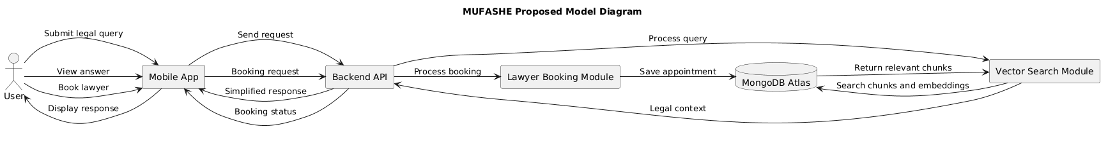
Figure 3.1: Proposed MUFASHE System

3.4 Class Diagram
The class diagram presents the main software classes in the MUFASHE system and their relationships. It shows how users interact with questions, appointments, and notifications, while documents are divided into chunks that support vector search. The diagram also illustrates the role of the backend API and vector search service in processing legal queries and generating responses.
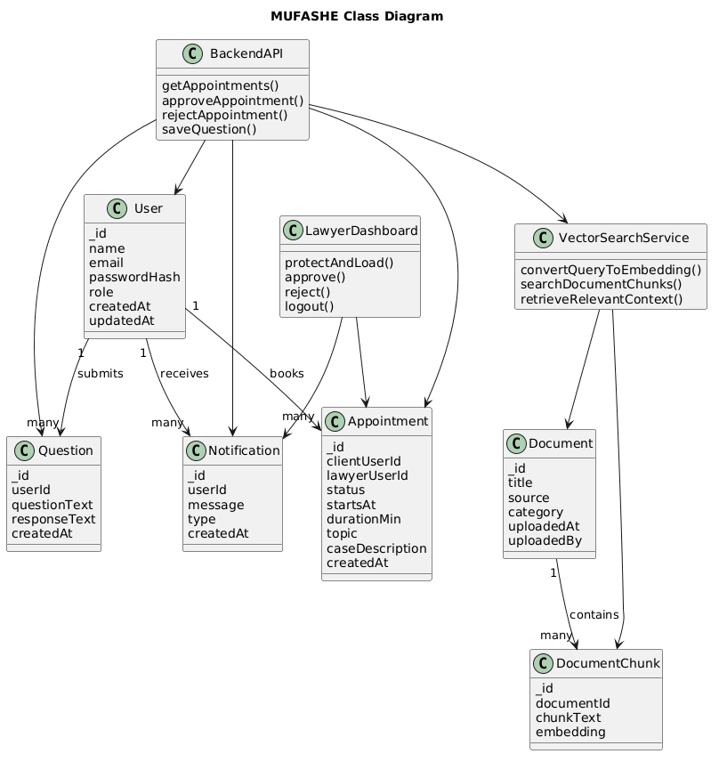
Figure 3.2: MUFASHE Class Diagram

3.5 Entity Relationship Diagram (ERD)
The Entity Relationship Diagram (ERD) represents the structure of the MUFASHE database and the relationships between its main collections. It shows that users can submit many questions, receive many notifications, and create appointments. It also shows that legal documents are divided into document chunks, which are used in vector similarity search. In the system, administrators, lawyers, and ordinary users are all represented within the users collection through the role field. Administrators are responsible for uploading legal documents into the system.
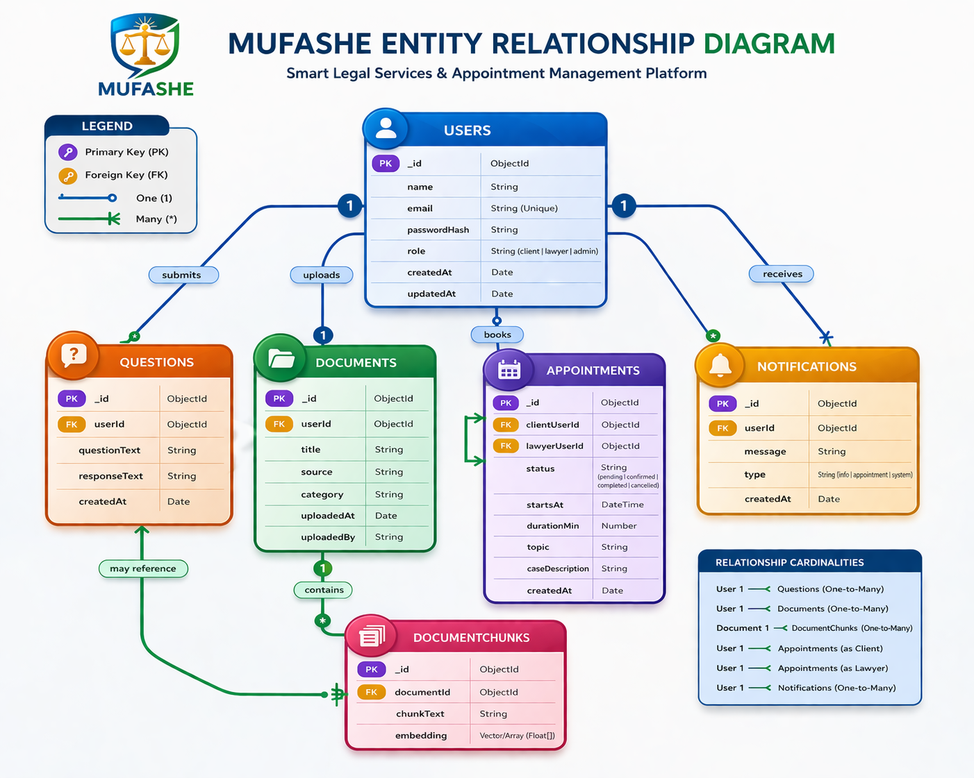
Figure 3.3: MUFASHE Entity Relationship Diagram (ERD)

3.6 System Architecture
The MUFASHE platform follows a client-server architecture composed of four main components.

Mobile Application
The mobile application was developed using React Native with Expo. The application allows users to submit legal questions, view responses, access legal documents, and book consultations with lawyers.

Backend API
The backend server was implemented using Node.js and Express. It handles API requests, authentication, communication with the database, and interaction with the vector search system.

Vector Search and Embedding System
The system uses embeddings and vector search to retrieve relevant legal information. Legal documents are divided into chunks and converted into vector embeddings. These embeddings are stored in MongoDB Atlas and used to perform similarity searches when users submit queries.

Database
The system uses MongoDB Atlas to store legal documents, embeddings, user data, appointments, notifications, and other system information.
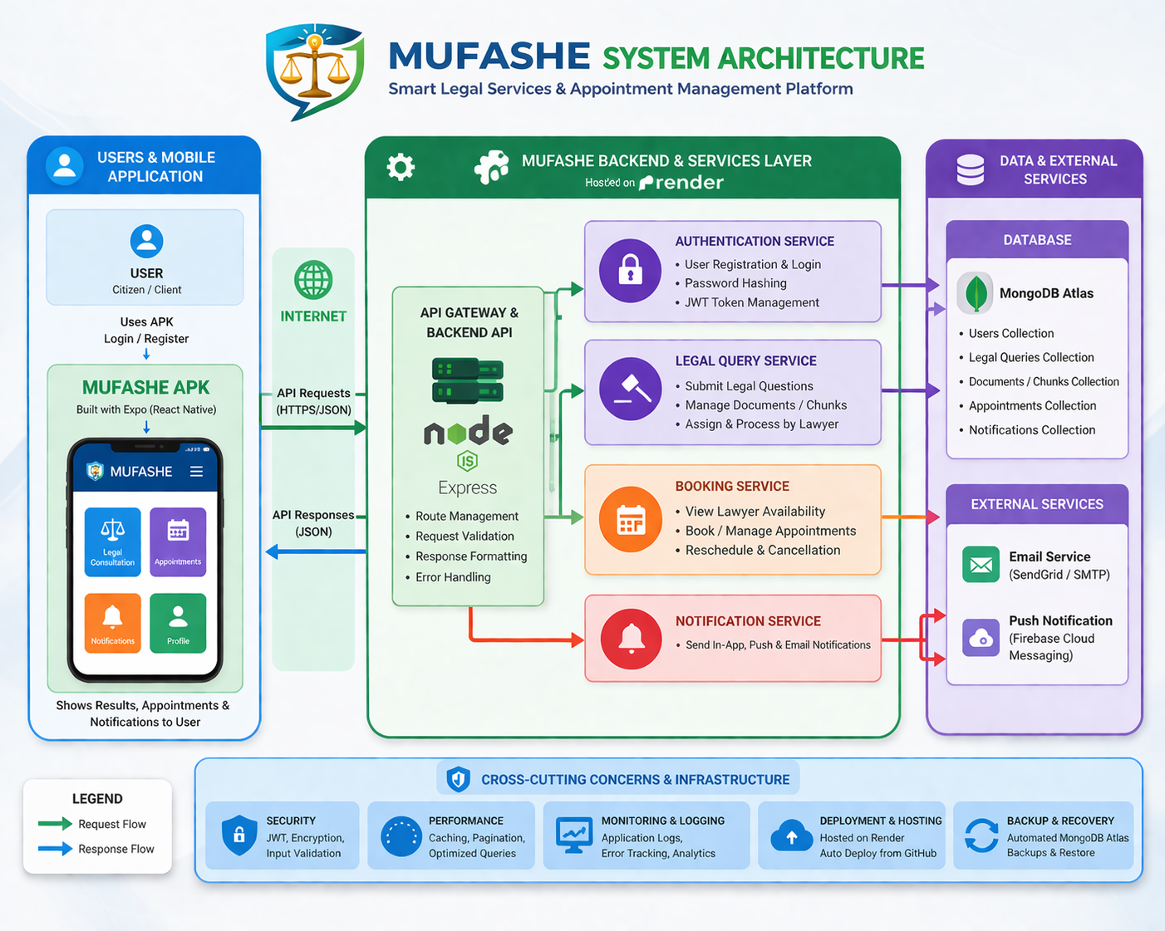
Figure 3.4: MUFASHE System Architecture Diagram

3.7 Flowchart
The flowchart illustrates the process followed when a user submits a legal question in MUFASHE, from query submission to vector search and response generation.
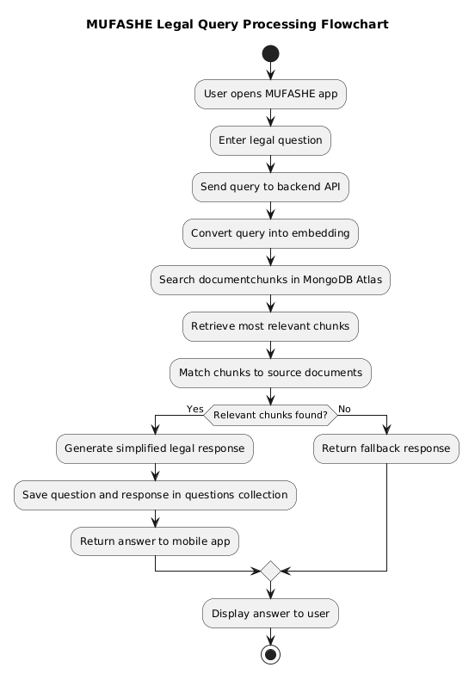
Figure 3.5: MUFASHE Legal Query Processing Flowchart

3.7.2 Use Case Diagram
The use case diagram illustrates how different actors interact with the MUFASHE platform. The main actors include the User, Lawyer, and Admin. Users can register, submit legal queries, receive legal guidance, browse lawyers, and book consultations. Lawyers can view booking requests, approve or reject appointments, and receive notifications. Admins can upload legal documents and manage users and lawyers.
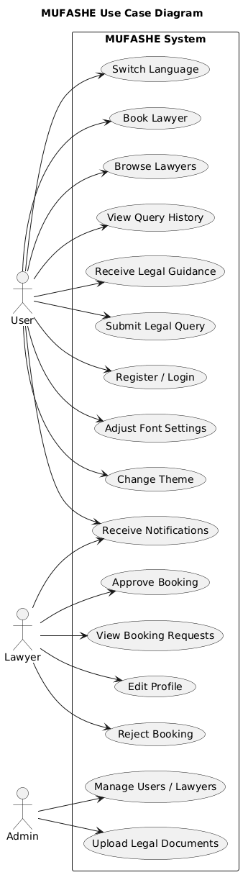
Figure 3.6: MUFASHE Use Case Diagram

3.7.3 Sequence Diagram for Legal Query Processing
The sequence diagram for legal query processing illustrates the communication between the mobile application, backend API, vector search module, and MongoDB Atlas when a user submits a legal question.

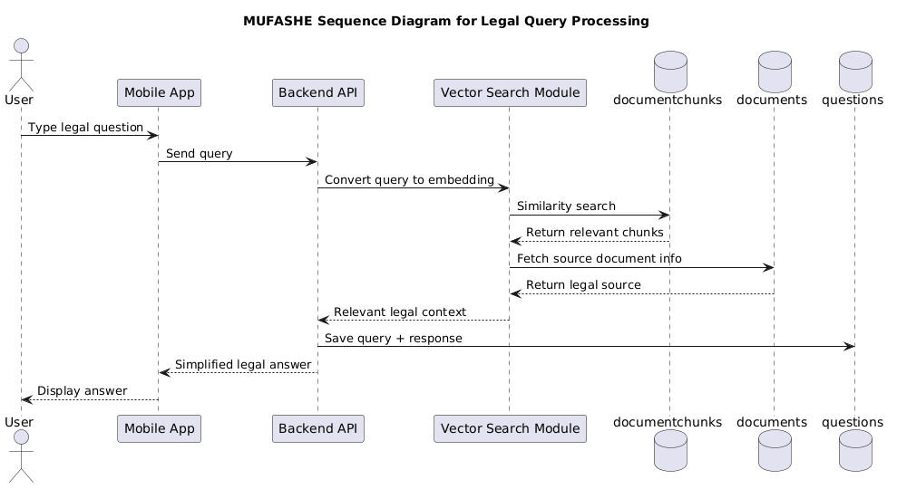
Figure 3.7: Sequence Diagram for MUFASHE Legal Query Processing

3.7.4 Sequence Diagram for Lawyer Booking
The sequence diagram for lawyer booking illustrates how a user books a lawyer through the mobile application and how the backend stores the appointment and returns the booking status.
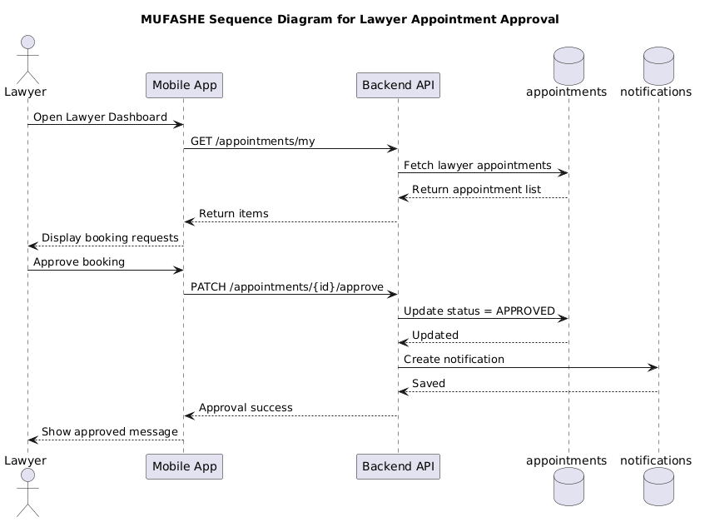
Figure 3.8: Sequence Diagram for MUFASHE Lawyer Booking

3.7.5 Database Collections Diagram
The database collections diagram illustrates the main MongoDB collections used in MUFASHE, including users, questions, documents, documentchunks, appointments, and notifications.
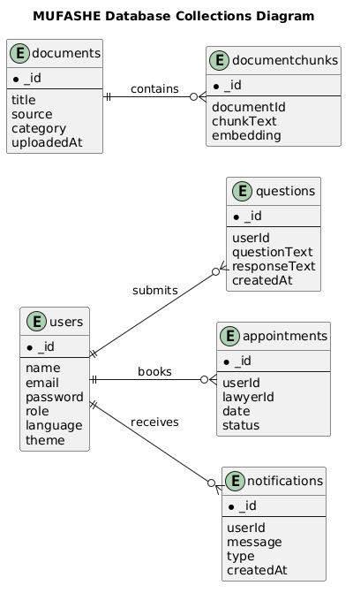
Figure 3.9: MUFASHE Database Collections Diagram

3.8 Development Tools
Several development tools and technologies were used to build and deploy the MUFASHE platform.
Tool | Purpose
React Native (Expo) | Mobile application development
Node.js and Express | Backend API development
MongoDB Atlas | Database and vector search storage
Embedding Model | Generating embeddings for legal document chunks
Postman | API testing
Thunder Client | API testing within VS Code
Render | Backend hosting platform
GitHub | Version control
Ngrok | Local API testing during development
Expo EAS | APK build for Android installation

API endpoints were tested extensively using Postman and Thunder Client before connecting the backend with the mobile application. The backend server was deployed on Render, while the mobile application was built as an APK using Expo EAS. After deployment, the mobile application successfully connected to the hosted backend service.

Chapter Summary
This chapter presented the system analysis and design of the MUFASHE platform. It described the research design and Agile SDLC model used during development, the dataset preparation process, and the functional and non-functional requirements of the system. The chapter also explained the proposed model, class diagram, ERD, system architecture, and the main design diagrams used to illustrate system operation. Finally, the development tools used to implement and deploy the platform were described.

CHAPTER 4: SYSTEM IMPLEMENTATION AND TESTING

4.1 Implementation and Coding
This section explains how the MUFASHE system was implemented based on the system design presented in the previous chapter. It describes how the main components of the system were developed and integrated to provide the required functionalities. The section also briefly presents the tools and technologies used during development and how they supported the implementation of the system modules.

4.1.1 Introduction
This subsection describes the implementation of the main components of the MUFASHE system. It focuses on how the mobile application, backend services, database, and AI-based legal query processing modules were developed and connected. The purpose of this subsection is to show how the designed system was translated into an operational application.

4.1.2 Description of Implementation Tools and Technology
The implementation of MUFASHE was done using a combination of frontend, backend, database, and artificial intelligence technologies. The mobile application was developed using React Native with Expo Router, which provided role-based navigation for authentication, user, lawyer, and admin screens. The frontend contains modules such as login, registration, dashboard, consult, library, lawyers, booking, history, notifications, profile, and settings.
The backend was implemented using Node.js and Express.js. It contains controllers, routes, models, middleware, and services that handle authentication, legal question processing, document upload, lawyer management, appointments, notifications, and administrative functions. MongoDB Atlas was used to store users, questions, documents, document chunks, appointments, and notifications.
To support AI-based legal guidance, uploaded legal PDF documents were processed through a pipeline that extracts text, splits it into chunks, generates embeddings, and stores them for vector search. When a user submits a legal question, the system retrieves the most relevant legal chunks and uses them to generate a grounded response with sources. The backend was deployed on Render, while the mobile application was built into an Android APK using Expo EAS for testing and demonstration

4.2 Graphical View of the Project
This section presents the graphical interfaces of the MUFASHE mobile application. The screenshots illustrate the main features of the system and demonstrate how users interact with the platform. The graphical view includes the welcome screen, user dashboard, consult interface for submitting legal questions, AI-generated responses, legal document library, lawyer directory, and administrative management interfaces. These screenshots highlight the key functionalities implemented in the system and show how the application supports users in accessing legal information and services.

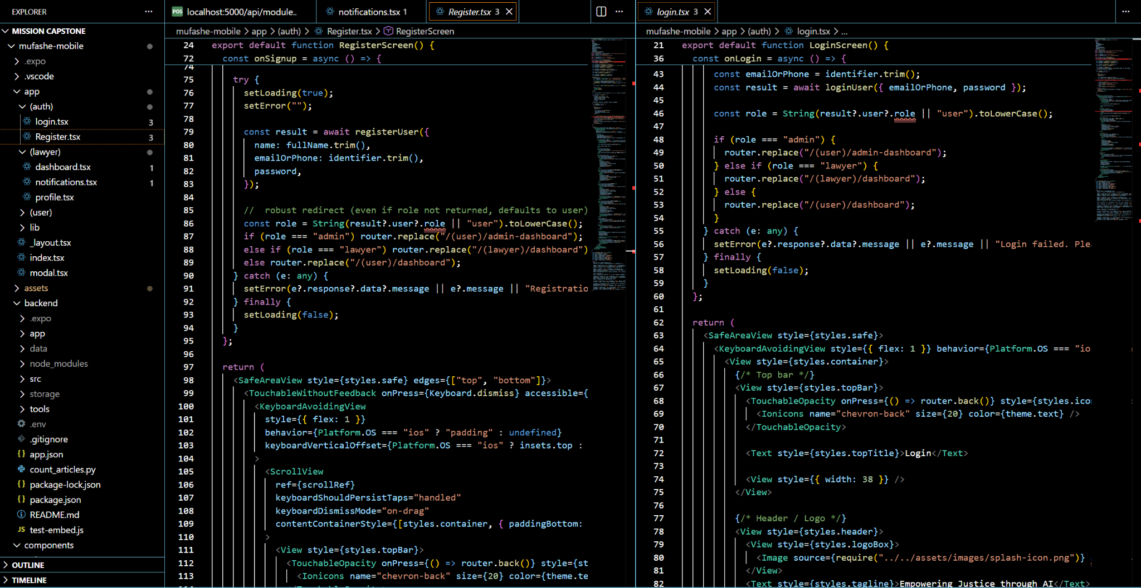
Figure: Register to app and Login

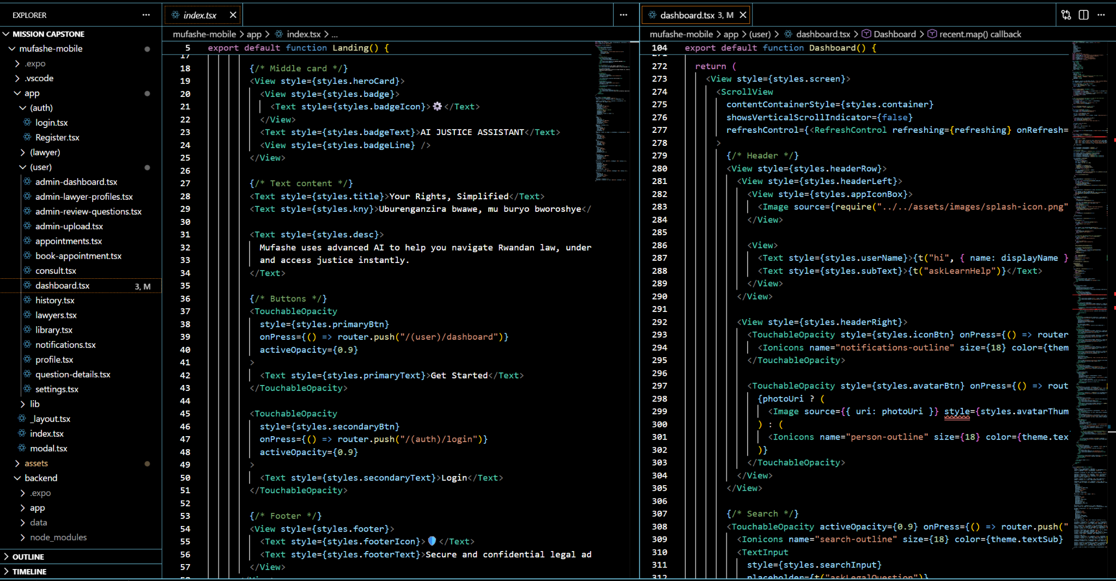

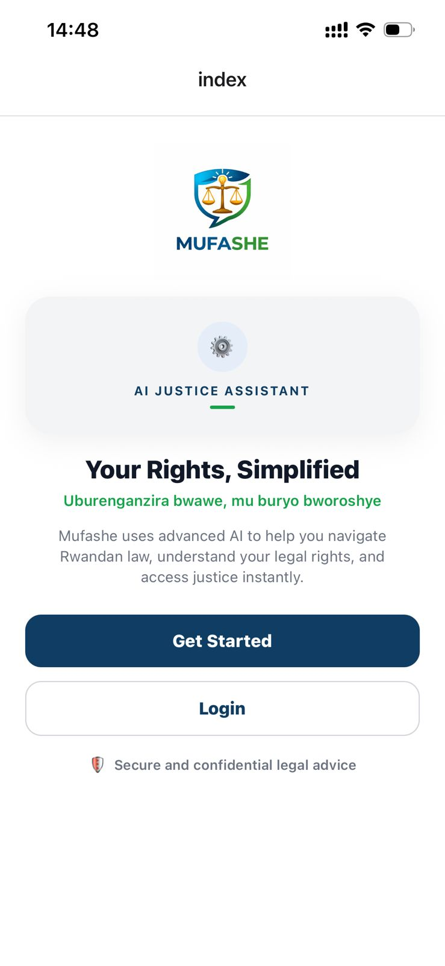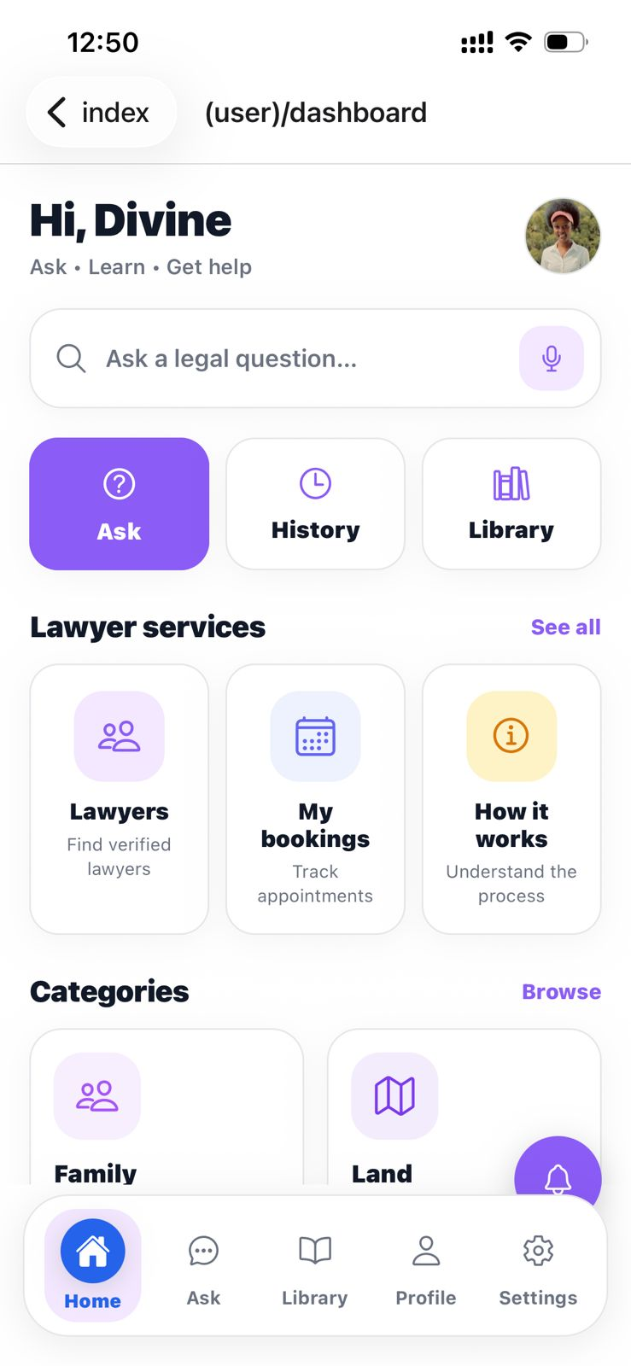
Figure 4.1 welcome page Figure 4.2 User Dashboard

Figure 4.1: Welcome Page
The welcome page is the first interface displayed when the MUFASHE mobile application is launched. This screen introduces users to the platform and briefly explains its purpose, which is to simplify access to legal information through artificial intelligence. The page provides navigation options that allow users to either create a new account or log into an existing account. The welcome interface also highlights the goal of the system, which is to help users understand their legal rights and access legal guidance in a simple and accessible way.

Figure 4.2 User Dashboard
The user dashboard serves as the main interface after a user successfully logs into the MUFASHE system. It provides quick access to the main features of the application, including asking legal questions, viewing question history, browsing the legal document library, and accessing the lawyer directory. The dashboard also displays legal categories such as family, land, labor, and business to help users navigate common legal topics. This interface improves usability by allowing users to quickly access the services provided by the platform.
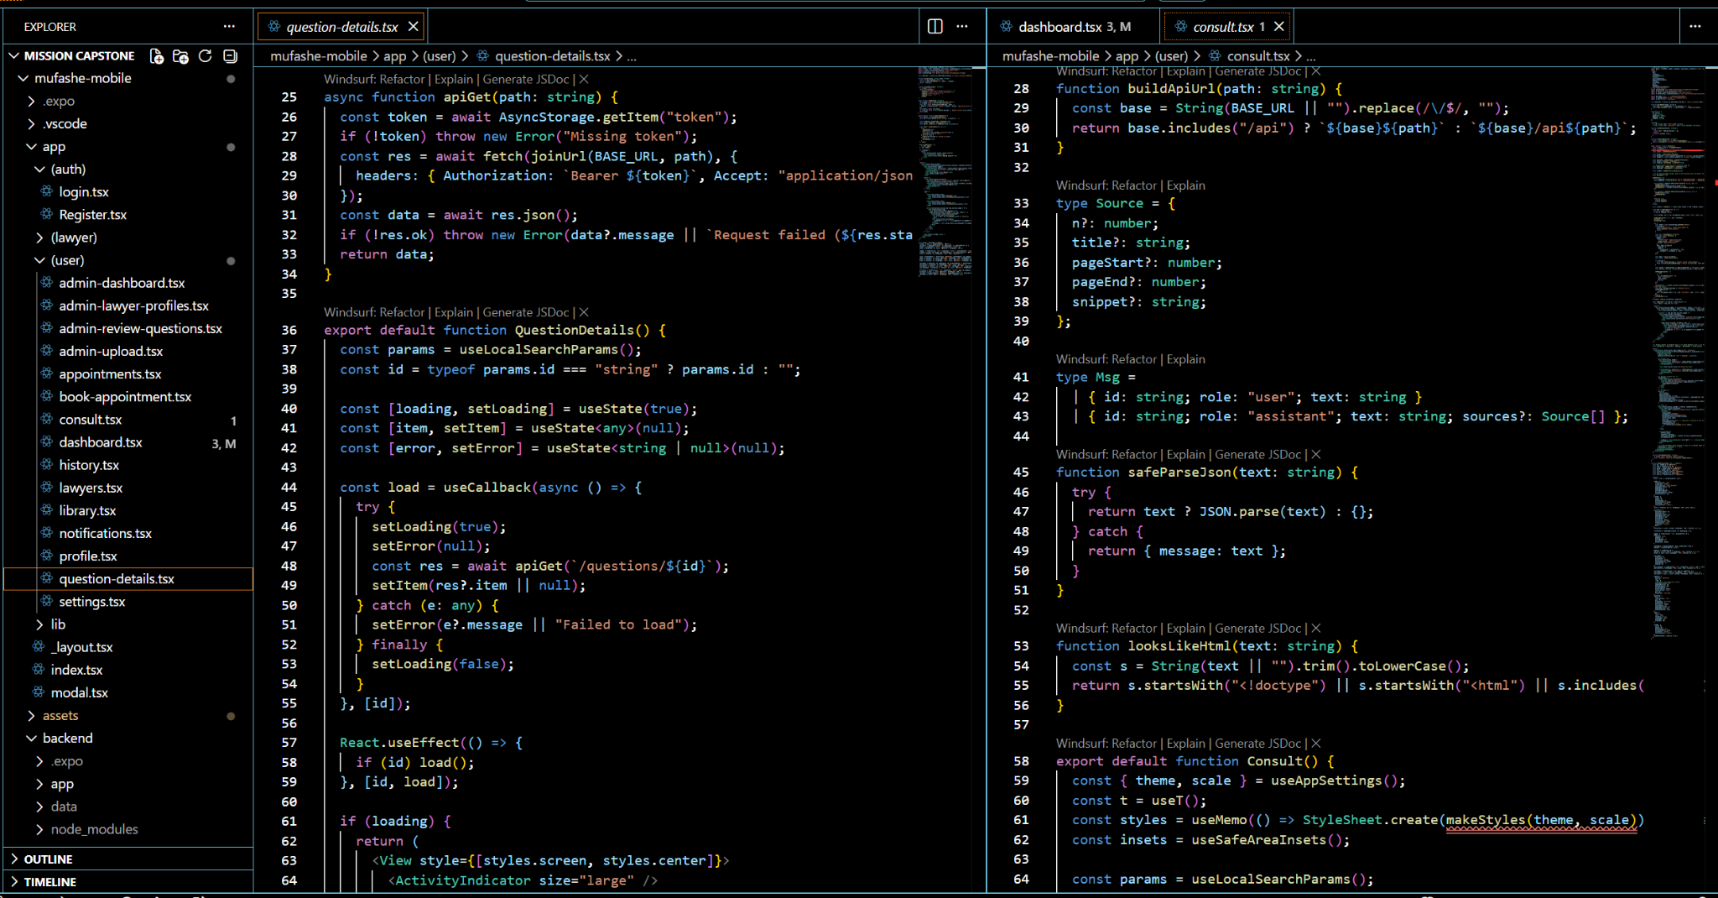
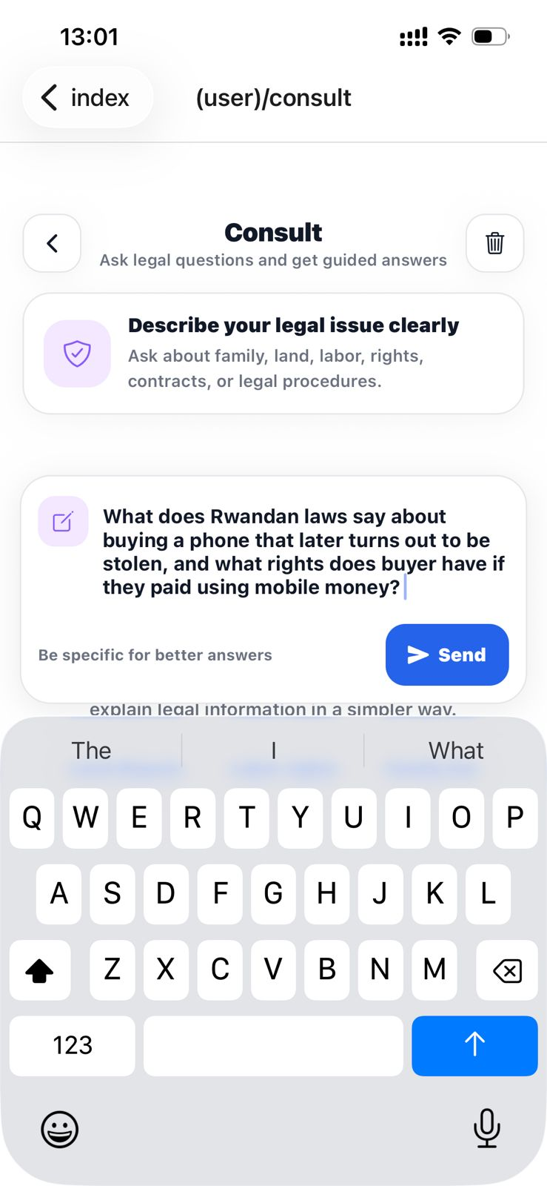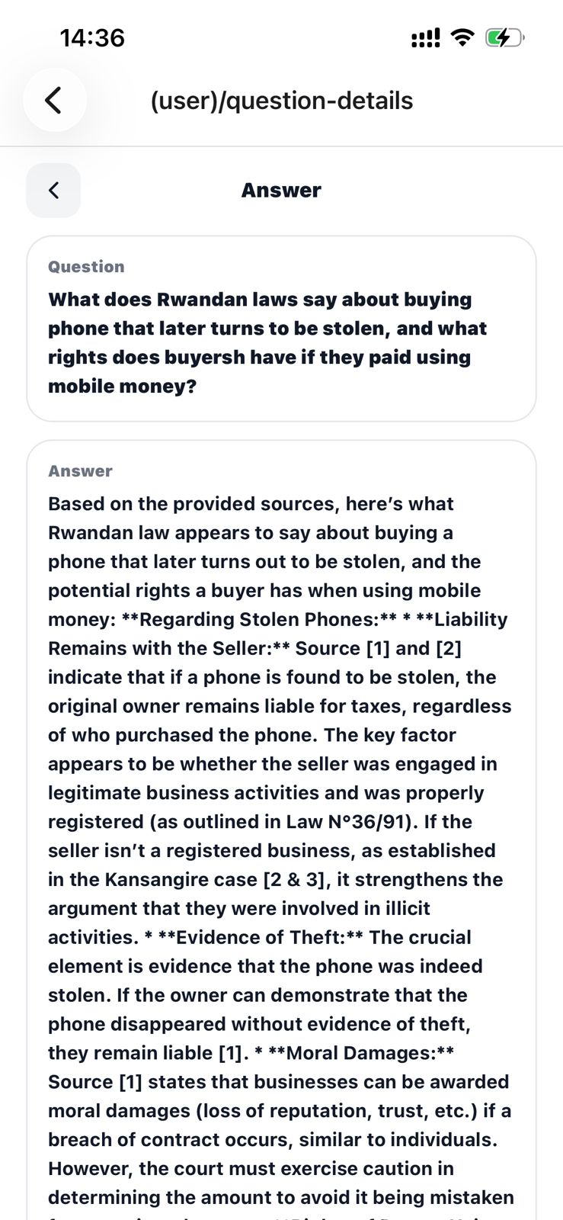
Figure 4.3 Consult screen Figure 4.4 AI answer / question details

Figure 4.3 Consult Screen
The consult screen allows users to submit legal questions to the MUFASHE system. Users can type their legal concerns directly into the input field provided on the interface. Once the question is submitted, the system sends the query to the backend server where it is processed using the AI-based legal retrieval system. This feature enables users to interact with the platform in a conversational way and obtain legal guidance based on verified legal documents.

Figure 4.4 AI Answer / Question Details
This screen displays the AI-generated response to the legal question submitted by the user. After the system retrieves relevant legal information using vector search, it generates a simplified explanation of the legal issue and presents it to the user. The interface also includes references to the legal sources used to generate the response, allowing users to view the legal basis for the explanation provided. This feature improves transparency and reliability by ensuring that the answers are grounded in actual legal documents.

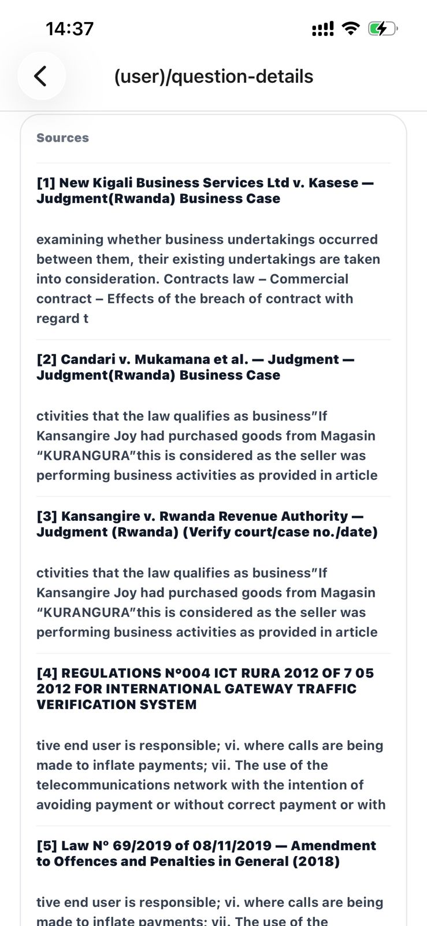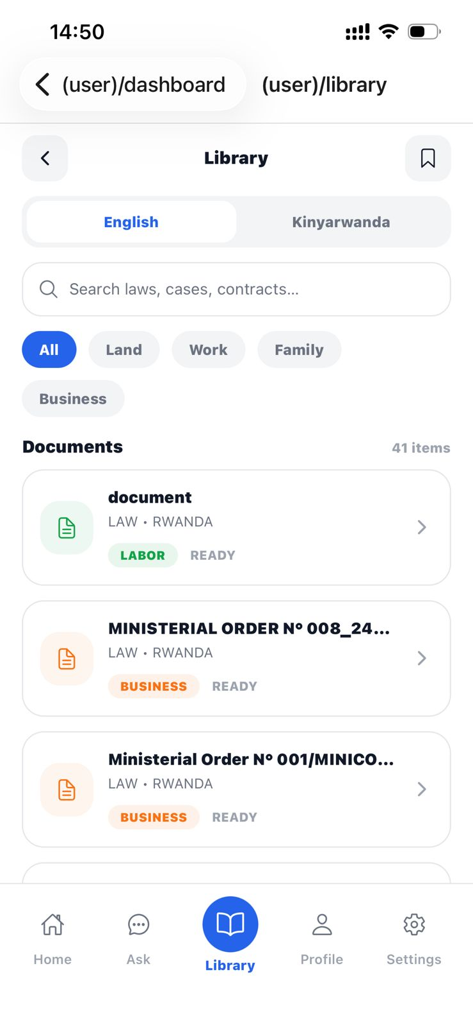
Figure 4.5 Legal library

Figure 4.5 Legal Library
The legal library screen provides users with access to legal documents stored in the MUFASHE knowledge base. Users can browse legal texts by category or search for specific laws using the search function. The platform also allows users to switch between English and Kinyarwanda to improve accessibility for different users. This feature ensures that users can directly explore legal documents that are used by the AI system to generate responses.

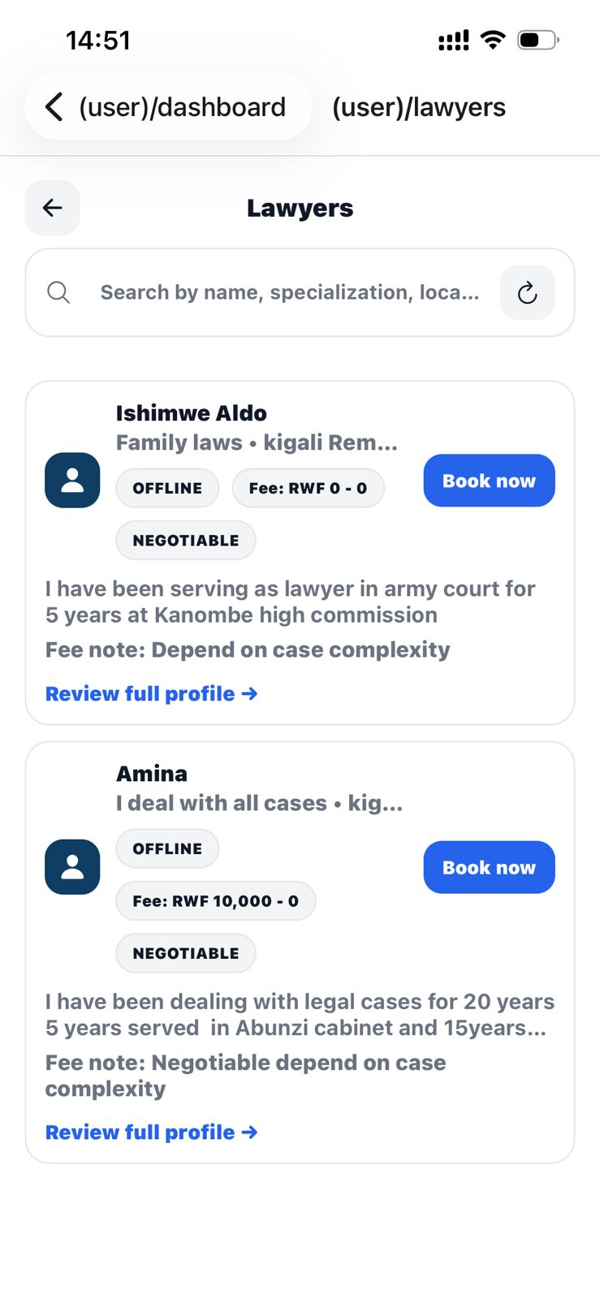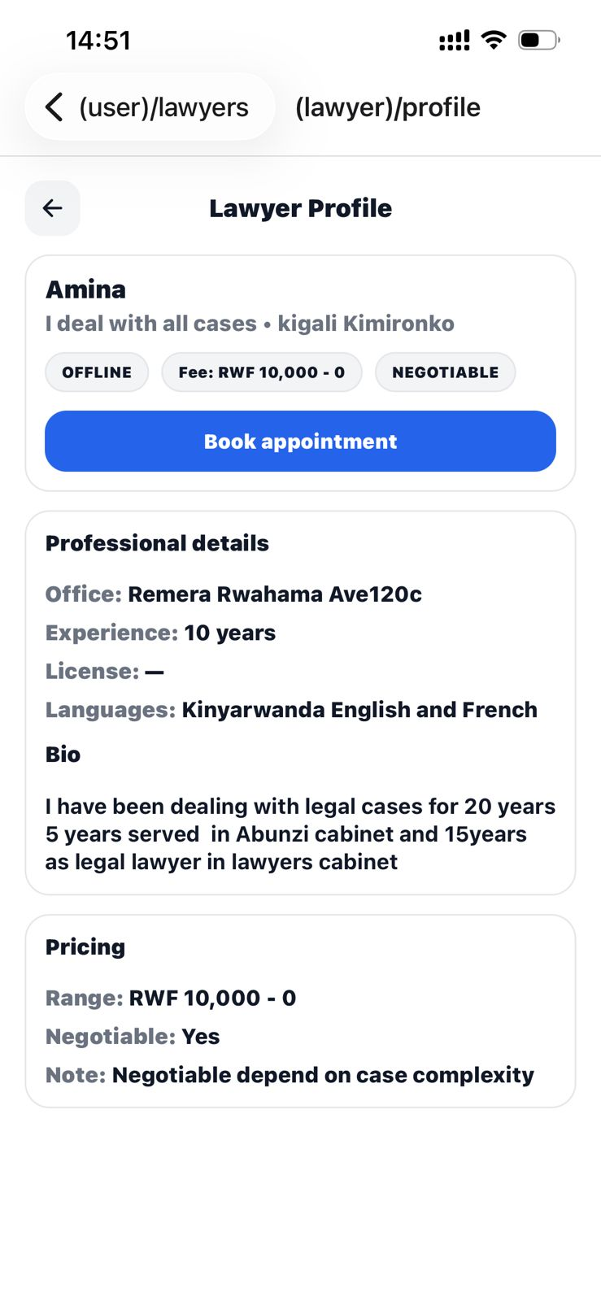
Figure 4.6 Lawyers directory

Figure 4.6 Lawyers Directory
The lawyers directory allows users to search and view profiles of available legal professionals. Each lawyer profile displays important information such as the lawyer’s specialization, location, experience, and consultation fee range. Users can view detailed profiles and request appointments with lawyers if their legal issues require professional legal assistance. This feature connects users with human legal experts when additional guidance is necessary.
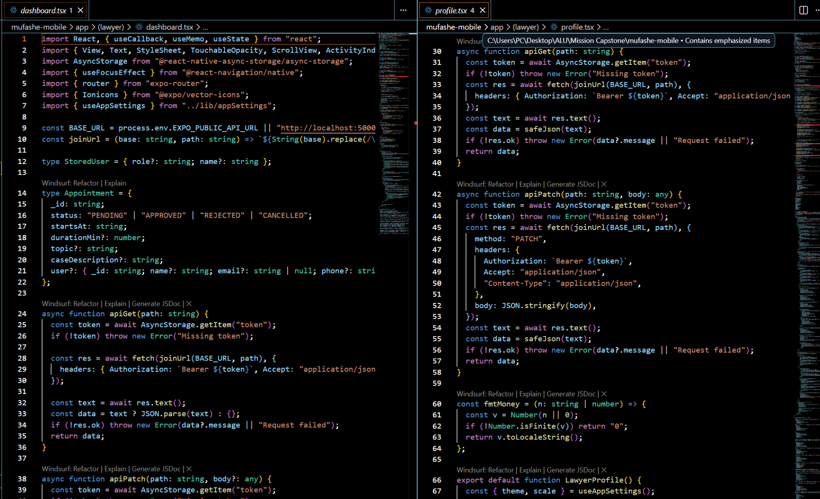

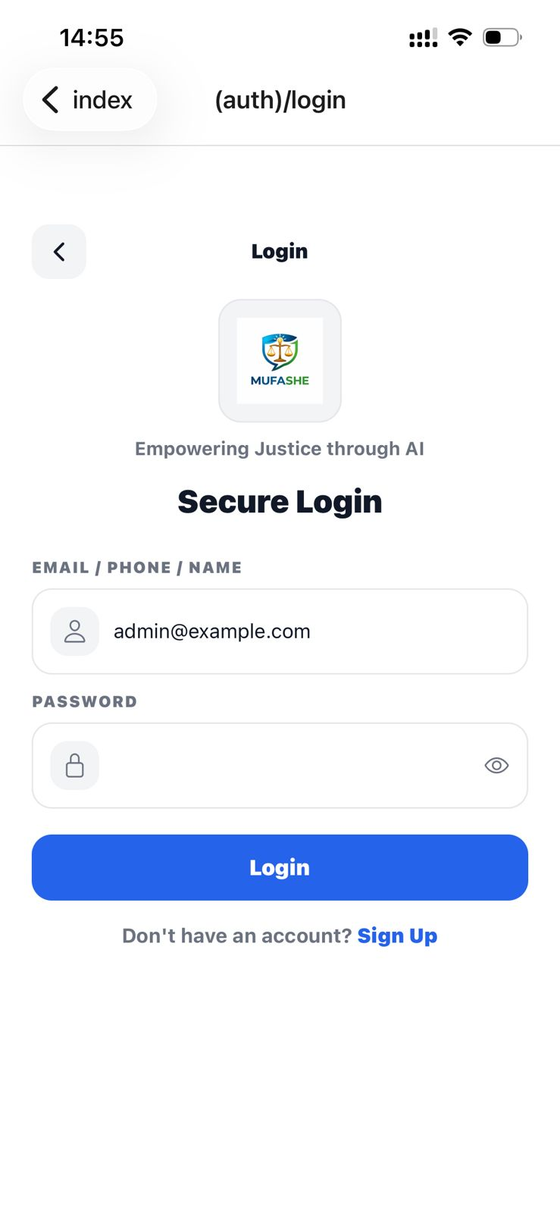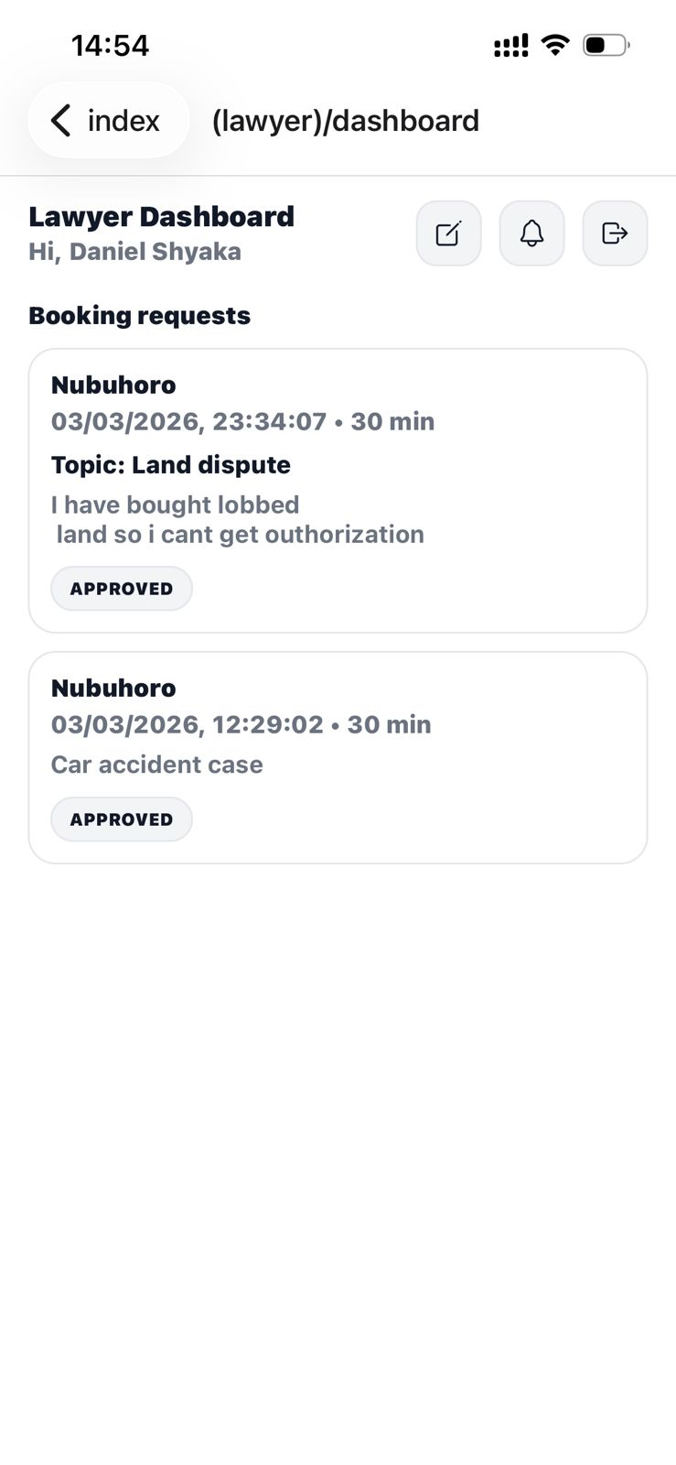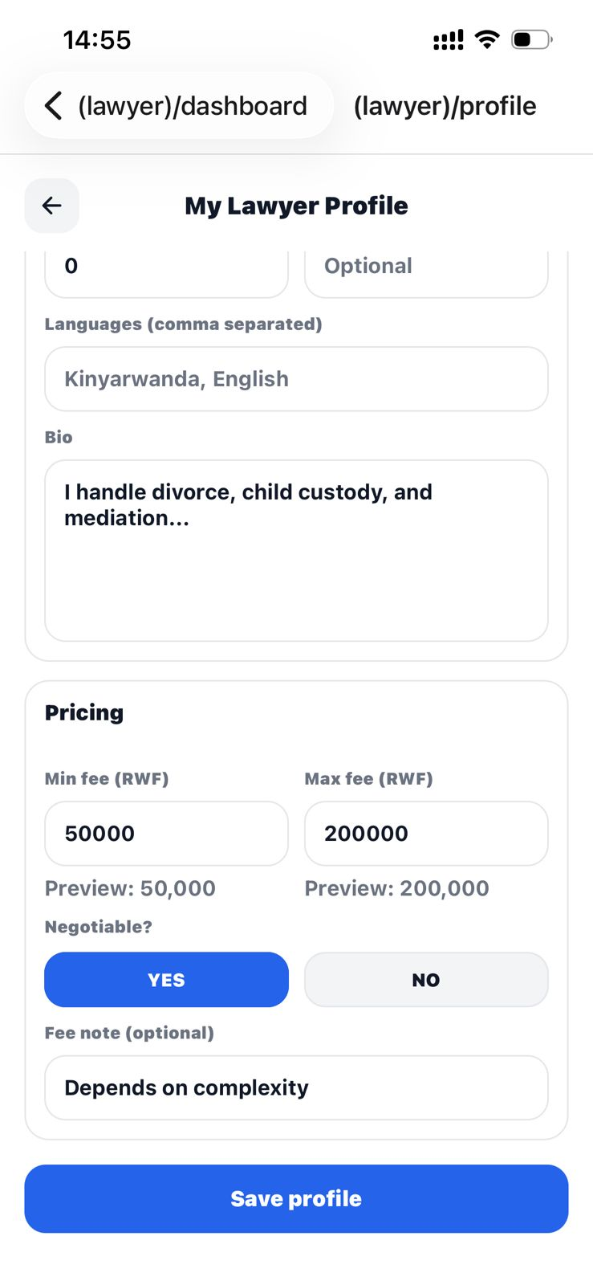
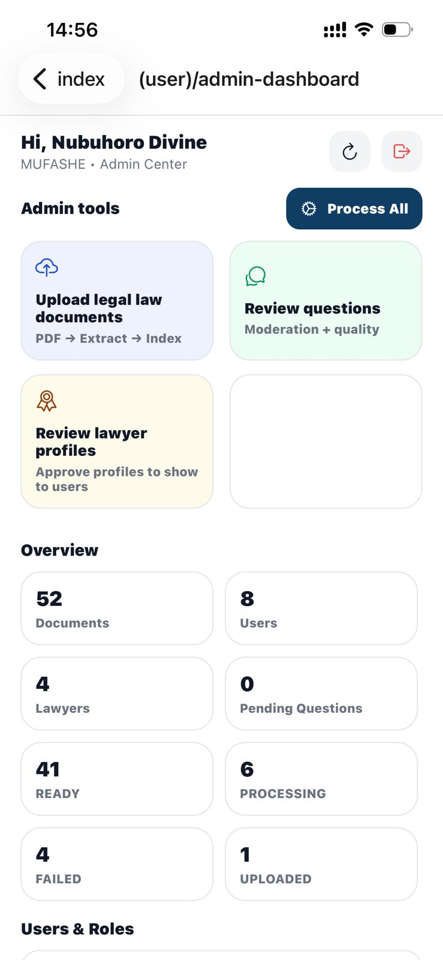
Figure 4.7 Admin Dashboard

Figure 4.7 Admin Dashboard
The admin dashboard provides administrative control over the MUFASHE platform. Administrators can monitor system activity, manage users and lawyer profiles, review submitted questions, and oversee the legal document processing pipeline. The dashboard displays system statistics such as the number of uploaded documents, registered users, lawyers, and processed legal document chunks. This interface helps administrators maintain the quality and reliability of the system.
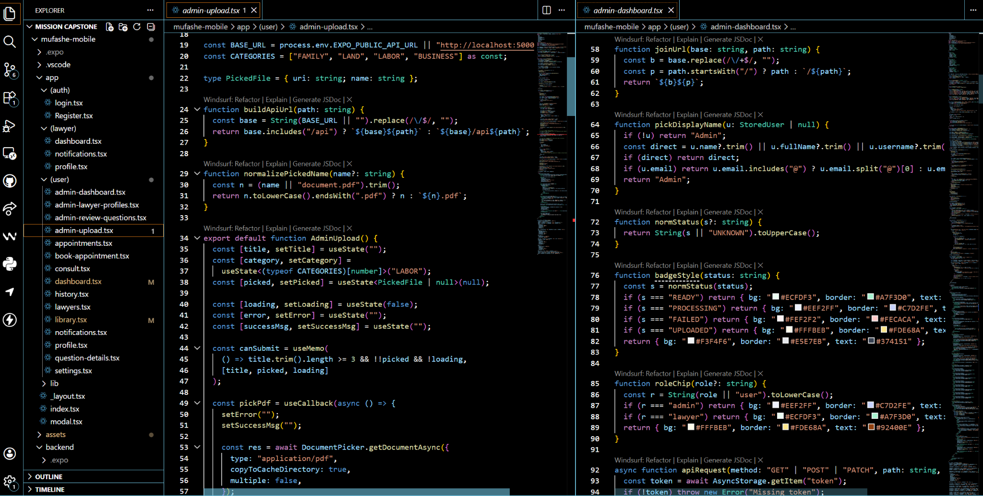
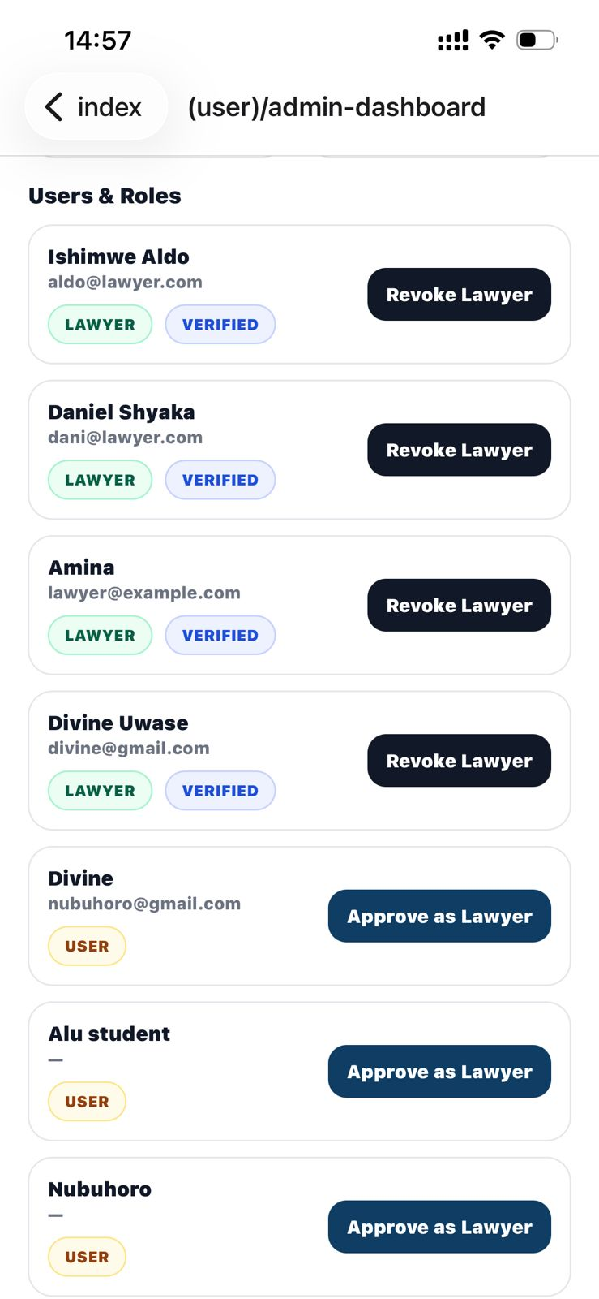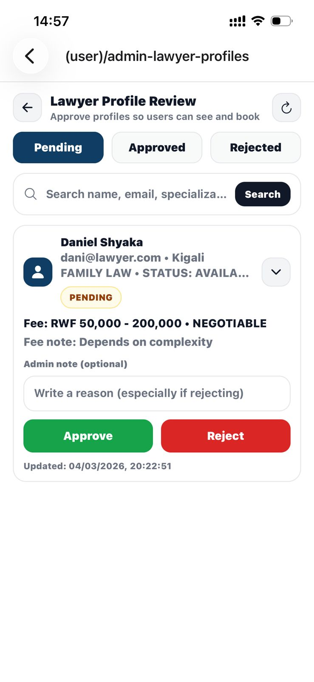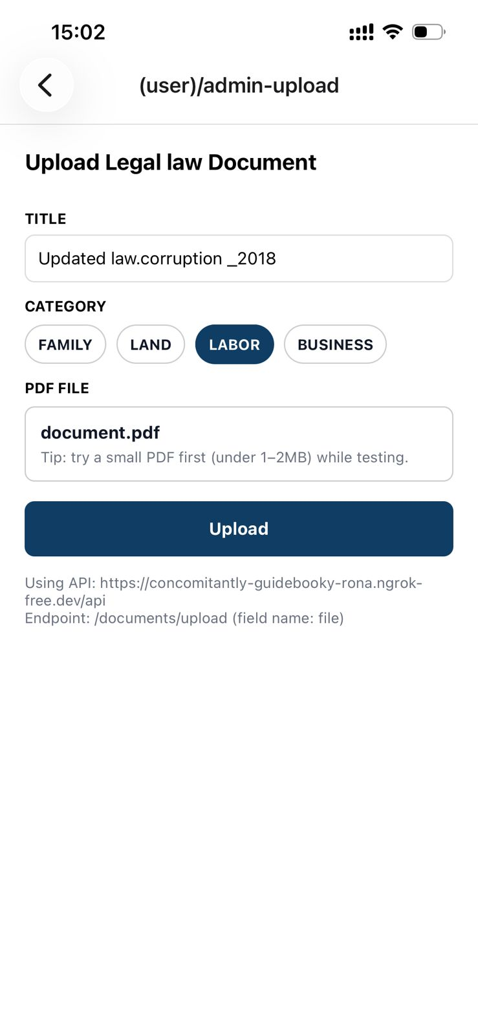
Figure 4.8 Admin document upload

Figure 4.8 Admin Document Upload
The admin document upload interface allows administrators to upload legal PDF documents into the system. When a document is uploaded, the backend processing pipeline extracts the text, divides it into smaller chunks, and generates vector embeddings that are stored in the database. These embeddings enable the system to perform similarity-based searches when users submit legal questions. This feature ensures that the MUFASHE system can continuously expand its legal knowledge base as new legal documents become available.

4.3 Testing

4.3.1 Introduction
The testing phase was conducted to ensure that the MUFASHE system functions correctly and meets the requirements defined during the system analysis and design stages. Testing focused on verifying that the mobile application, backend API, database, and AI-based legal query processing components worked together properly. Different types of testing were performed, including unit testing, validation testing, integration testing, functional testing, and user acceptance testing. These tests helped confirm that the system could successfully process legal queries, retrieve relevant legal information, manage lawyer bookings, and allow administrators to manage legal documents.

4.3.2 Objective of testing
The objective of testing the MUFASHE system was to verify that all system components function correctly and that the platform meets its intended purpose of providing accessible legal guidance to users. The testing process aimed to ensure that the mobile application interface operates properly, that the backend APIs correctly process user requests, and that the system can retrieve relevant legal information from the document knowledge base. In addition, testing was conducted to confirm that users can successfully register, log in, submit legal questions, view AI-generated responses, browse legal documents, and book appointments with lawyers. The testing process also ensured that administrators can upload legal documents and manage system resources effectively.

4.3.3 Unit Testing Outputs
Unit testing was carried out in the MUFASHE system to ensure that individual backend components function correctly when tested independently. The testing process was implemented using the Jest framework, which allowed automated execution of test cases across different parts of the system.

4.3.3.1 Overall Test Performance
The system achieved strong results during testing, as shown in this table (table 4.1)
Table 4.1: Summary of Unit Testing Results
Metric | Result
Total Test Suites | 24
Total Test Cases | 186
Tests Passed | 186
Tests Failed | 0
Success Rate | 100%
These results show that all the implemented test cases passed successfully, indicating that the system behaves as expected.

4.3.3.2 Code Coverage Results
The overall code coverage achieved is presented in Table 4.2.
Table 4.2: Code Coverage Summary
Coverage Type | Percentage
Statements | 83.61%
Lines | 85.66%
Functions | 76.82%
Branches | 64.89%
The results indicate that most of the system logic was tested, especially the key functionalities of the backend.

4.3.3.3 Coverage by System Components
A breakdown of coverage across system components is shown in Table 4.3.
Table 4.3: Coverage by System Layer
System Component | Coverage
Middleware | 100%
Models | 100%
Utilities | 100%
Services | 97.17%
Controllers | 92.44%
Routes | 50.45%
As shown above, the core components of the system, such as services and controllers, achieved high coverage. These components handle the main logic of the system, including document processing, authentication, and legal question answering.

4.3.3.4 Testing of Core Functionalities
The unit tests covered several important system functionalities. For example:
- User Authentication: Verified login, registration, and role-based access control.
- Legal Question Handling: Ensured that invalid or empty inputs are rejected, while valid questions are processed correctly.
- AI-Based Question Answering: Confirmed that the system retrieves relevant legal document chunks and returns answers with sources.
- Document Processing: Tested PDF upload, text extraction, and chunking.
- Semantic Search: Verified that relevant information is retrieved using vector similarity.
- Middleware Protection: Ensured that unauthorized access is blocked.

4.3.3.5 Manual API Testing
In addition to automated testing, manual API testing was performed using Postman and Thunder Client. This helped to verify real interactions between the frontend and backend.
For example, the system was able to:
- Authenticate users and generate tokens
- Process and store user questions
- Retrieve relevant legal information
- Enforce role-based access control

4.3.3.6 Limitations
Although the results were strong, some areas had lower coverage:
Table 4.4: Areas with Lower Coverage
Component | Coverage
Routes | 61.45%
Google Auth Controller | 30.35%
This is mainly because:
- Route files contain minimal logic
- External integrations (e.g., Google authentication) depend on third-party services
However, these limitations do not significantly affect the main system functionality.

4.3.3.7 Overall Unit testing Evaluation
Overall, the unit testing process improved the reliability of the MUFASHE system. All test cases passed successfully, and the most important components achieved high coverage.
This indicates that the system is stable, secure, and capable of delivering accurate legal information to users.

4.3.4 Validation Testing Outputs
Validation testing was conducted to ensure that the MUFASHE system meets the requirements defined during the system analysis stage and that it correctly handles user inputs.
The testing focused on verifying that the system accepts valid data and rejects invalid or incomplete inputs. For example, users were required to enter valid login credentials before accessing the platform. During testing, incorrect login details were rejected, while valid credentials allowed successful access.
In addition, the legal question submission feature was tested. The system successfully prevented users from submitting empty or very short questions, while valid questions were processed correctly by the backend system. Similarly, the document upload module was tested to ensure that only PDF files are accepted, and unsupported file formats were rejected.
The validation results confirmed that the system enforces input rules consistently and prevents invalid data from entering the system. This helps maintain data integrity and ensures reliable system operation.

4.3.5 Integration Testing Outputs
Integration testing was conducted to verify that different components of the MUFASHE system work correctly when combined together. The system consists of multiple modules, including the mobile application, backend API, database, and AI-based legal retrieval system.
During testing, the interaction between the mobile application and backend was evaluated. For example, when a user submits a legal question through the consult interface, the request is sent to the backend, processed using vector similarity search, and the response is returned to the mobile application. The results presented in Chapter 5 confirm that the system was able to retrieve relevant legal information and return responses within a short time.
Integration testing was also performed for the lawyer booking module. Users were able to view lawyer profiles and submit appointment requests successfully. These requests were stored in the database and retrieved correctly through the appointments interface.
In addition, the document upload and processing pipeline was tested. Uploaded legal documents were successfully processed into chunks and embeddings, making them available for semantic search and AI-based responses.
These results confirm that the different system components are properly integrated and able to function together to support the platform’s core services.

4.3.6 Functional and System Testing Results
Functional and system testing were conducted to evaluate whether the MUFASHE system performs all required functions and meets both functional and non-functional requirements defined during the system design phase.

Functional Testing Results
Functional testing focused on verifying that the system features operate correctly according to the specified functional requirements. The results are summarized in Table 4.5.
Table 4.5: Functional Testing Results
Functional Requirement | Expected Result | Actual Result | Status
User Registration | Users can create accounts successfully | Accounts created and stored in database | Pass
User Login | Users can log in with valid credentials | Login successful, invalid credentials rejected | Pass
Legal Question Submission | Users can submit valid legal questions | Questions submitted and processed correctly | Pass
AI Legal Response Generation | System returns answers with legal references | Responses generated with relevant sources | Pass
Legal Document Retrieval | Users can browse and search legal documents | Documents displayed and searchable | Pass
Lawyer Directory | Users can view lawyer profiles | Profiles displayed correctly | Pass
Lawyer Booking | Users can book appointments | Booking stored and retrieved successfully | Pass
Admin Document Upload | Admin can upload PDF documents | Documents uploaded and processed correctly | Pass
The results show that all core functionalities of the MUFASHE system were successfully implemented and tested.

System Testing (Non-Functional Requirements) Results
System testing focused on evaluating how well the system performs as a complete integrated application. This included performance, usability, reliability, and security aspects. The results are summarized in Table 4.6.
Table 4.6: Non-Functional Testing Results
Non-Functional Requirement | Expected Result | Actual Result | Status
Performance | Fast response time when submitting queries | Responses returned within a short time (3 minutes ) | Pass
Usability | Easy navigation and user-friendly interface | Users able to navigate system without difficulty | Pass
Reliability | System operates without crashes or major errors | No major failures observed during testing | Pass
Security | Unauthorized access should be prevented | Authentication and role-based access working correctly | Pass
Data Integrity | Data should be stored and retrieved accurately | Data stored and retrieved correctly from database | Pass
Scalability | System should handle increasing data (documents/users) | System supports addition of documents and users | Pass

The results presented in Chapter 5 further confirm that the system successfully processes user requests, retrieves relevant legal information using vector similarity search, and returns responses through the mobile interface without major errors.
Overall, the MUFASHE system meets both functional and non-functional requirements defined during the system design phase. This indicates that the system is reliable, efficient, and capable of supporting users in accessing legal information through a mobile platform.

4.3.7 Acceptance Testing Report
Acceptance testing was conducted to evaluate whether the MUFASHE system meets the needs of its intended users and achieves the project objectives.
During this phase, users interacted with the system by performing real tasks such as creating accounts, logging in, submitting legal questions, viewing AI-generated responses, browsing legal documents, and booking appointments with lawyers. Administrators also tested system management features such as uploading and processing legal documents.
A user evaluation survey was conducted with 15 participants, and the results are presented in Chapter 5. The findings showed that:
- 100% of users found the AI legal assistant useful
- 100% of users indicated they would recommend the system
- Most users rated the system as easy or moderately easy to use
- The AI question-answering feature was selected as the most useful feature by 93.3% of participants
These results indicate a high level of user satisfaction and acceptance of the system.
Based on the acceptance testing results, the MUFASHE platform meets its intended objectives and is suitable for demonstration and further improvement.

4.4 Chapter Summary
This chapter presented the implementation and testing of the MUFASHE system. It described how the system was developed using modern technologies including React Native for the mobile application, Node.js and Express.js for the backend services, and MongoDB Atlas for data storage.
The chapter also illustrated how users interact with the system to submit legal questions, access legal documents, view lawyer profiles, and manage administrative functions.
Furthermore, several testing methods were conducted to evaluate the performance and reliability of the system. These included unit testing, validation testing, integration testing, functional testing, and acceptance testing.
The results, supported by both automated tests and user evaluation, confirm that the MUFASHE system operates reliably and meets its intended objectives. The system is capable of providing accessible legal information, supporting user interaction, and integrating multiple components into a functional platform.

CHAPTER 5: THE DESCRIPTION OF THE RESULTS/SYSTEM

5.1 Introduction
This chapter presents the main results obtained after implementing and testing the MUFASHE system. The purpose of this chapter is to evaluate how effectively the developed platform improves access to legal information and supports users in understanding legal issues.
The evaluation focuses on several aspects of the system, including system performance, user interaction with the platform, administrative system functionality, and user feedback collected through a survey. The discussion highlights how the main features of the MUFASHE platform operate in practice. These features include user authentication, submission of legal questions, AI-based legal guidance, retrieval of legal documents, lawyer directory and booking functionality, and administrative document management.
In addition to system testing, a user evaluation survey was conducted to measure the usability and usefulness of the platform. The survey collected responses from 15 participants, and the results were analyzed using charts generated from Google Forms. These results help assess user satisfaction, system usability, and the effectiveness of the AI legal assistant.
The findings presented in this chapter provide insight into how well the MUFASHE system achieves the objectives defined earlier in the study.

5.2 System Performance Results
The performance of the MUFASHE platform was evaluated based on its ability to process user requests and retrieve relevant legal information from the legal document knowledge base.
When users submit a legal question through the consult interface, the system converts the query into a vector embedding and performs similarity search against embeddings generated from stored legal document chunks in MongoDB Atlas. The system then retrieves the most relevant sections of legal documents and uses them to generate a simplified explanation of the legal issue.
Testing showed that the system successfully identified relevant legal sections for most queries. The responses generated by the platform included simplified explanations together with references to the original legal documents. This improves transparency and allows users to verify the legal basis of the information provided.
The testing process also showed that the platform can return results within a short response time after a user submits a question. The integration of vector embeddings and similarity search therefore proved effective in linking user queries with the most relevant sections of legal texts.
Overall, these results demonstrate that the MUFASHE system is capable of delivering grounded and useful legal guidance based on verified legal information.

5.3 User Interaction Results
The MUFASHE mobile application interface was designed to provide a simple and user-friendly experience. During testing, users were able to successfully perform key actions within the platform.
Users were able to create accounts, log into the system, and navigate the dashboard without major difficulties. Through the consult feature, users could submit legal questions and receive AI-generated explanations based on relevant legal documents.
In addition, users were able to browse the legal document library and explore different legal categories. The lawyer directory feature allowed users to view profiles of available lawyers and request consultations when professional legal assistance was required.
The query history feature allowed users to review their previous legal questions and responses, which helped users revisit earlier guidance when necessary. These results demonstrate that the system supports users not only in obtaining legal information but also in connecting with legal professionals when needed.

5.4 Administrative System Results
The administrative part of the MUFASHE system provides tools for managing the legal knowledge base and monitoring system activity.
Administrators are able to upload legal PDF documents through the admin dashboard. When a document is uploaded, the system automatically processes the file by extracting text, dividing it into smaller chunks, and generating embeddings used for vector search. After processing, the legal documents become searchable within the system and can be used by the AI retrieval component when answering user questions.
The admin dashboard also provides an overview of system statistics, including the number of registered users, available lawyers, uploaded legal documents, and processed document chunks. Through these features, administrators are able to monitor the system and maintain the quality of legal information stored in the knowledge base.
These administrative capabilities ensure that the MUFASHE platform remains reliable and can continuously expand its legal dataset as new legal documents become available.

5.5 User Evaluation Results
To evaluate the usability and usefulness of the MUFASHE system, a survey was conducted with 15 participants. The survey results were analyzed using charts generated from Google Forms.

5.5.1 Age Distribution of Respondents
The age distribution of participants shows that the majority of respondents were between 18–25 years old, representing 66.7% of participants. Participants aged 36–45 accounted for 20%, while those aged 26–35 represented 13.3%.
This indicates that the system was mainly evaluated by young adults, who are more likely to rely on mobile technologies for accessing information and digital services.
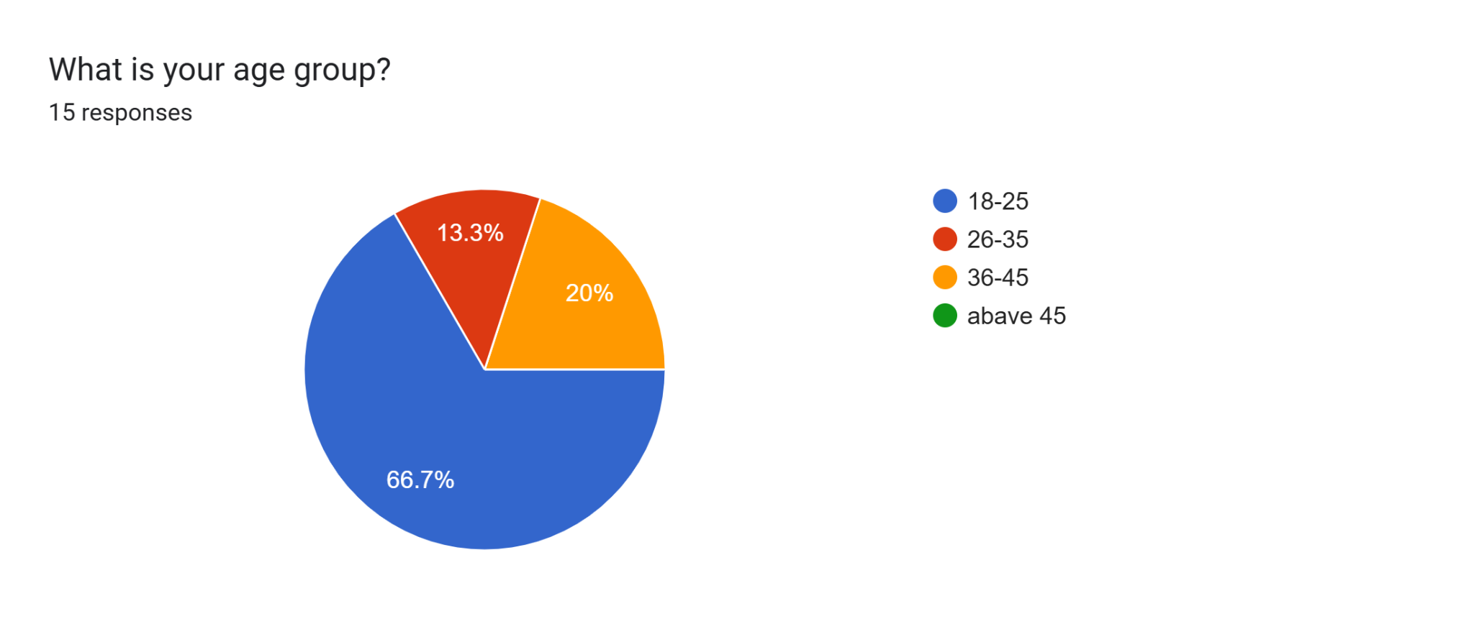

5.5.2 Occupation of Respondents
The survey also examined the occupations of participants.
The results show that:
- 66.7% were students
- 20% were self-employed
- 6.7% were employed
- 6.7% were legal professionals
This distribution suggests that MUFASHE may be particularly useful for students and young professionals who may not have direct access to legal advice but still need legal information.
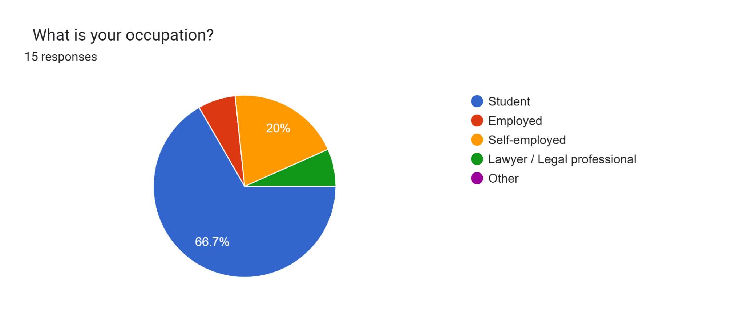

5.5.3 System Usability Evaluation
Participants were asked to rate how easy it was to navigate and use the MUFASHE mobile application on a scale from 1 (very difficult) to 5 (very easy).
The results showed that:
- 46.7% rated usability as 3
- 33.3% rated usability as 4
- 13.3% rated usability as 5
- 6.7% rated usability as 2
- No respondents rated usability as 1
These results indicate that most users found the system moderately easy to use, while many users considered the application easy or very easy to navigate.
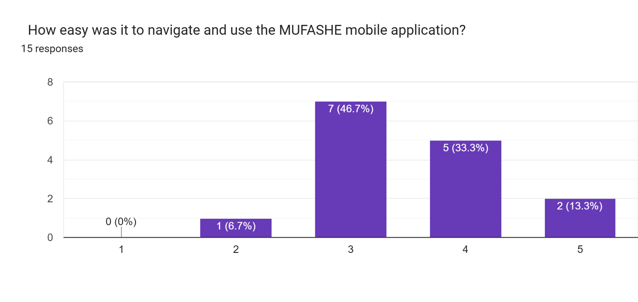

5.5.4 Evaluation of AI Legal Assistance
Participants were asked whether the AI legal assistant provided useful answers to their legal questions.
The results show that 100% of respondents indicated that the AI assistant provided useful answers.
This demonstrates that the AI retrieval system was able to provide meaningful explanations of legal issues and assist users in understanding legal information more clearly.
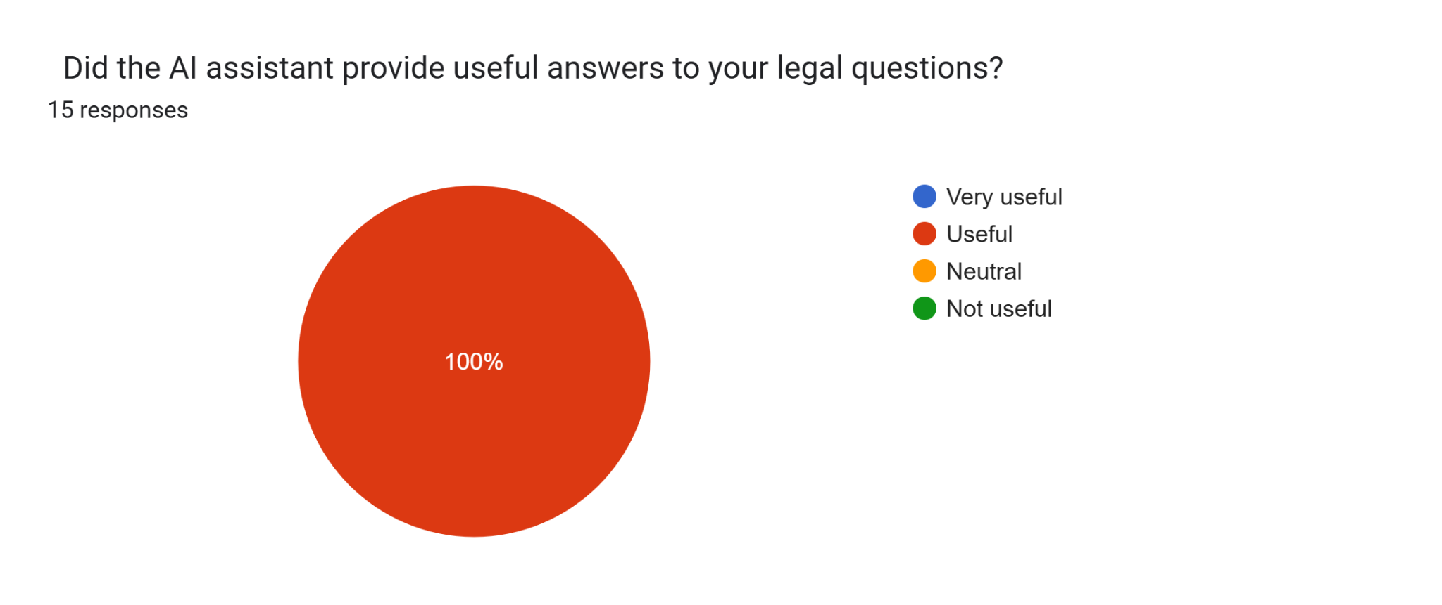

5.5.5 Accuracy of Legal Information
Participants were also asked to rate the accuracy of the legal information provided by the system.
The results indicate that:
- 66.7% rated accuracy as 2
- 20% rated accuracy as 4
- 6.7% rated accuracy as 3
- 6.7% rated accuracy as 1
Although users generally found the system useful, the results suggest that further improvements in accuracy could be achieved by expanding the legal document dataset and improving the AI retrieval model.
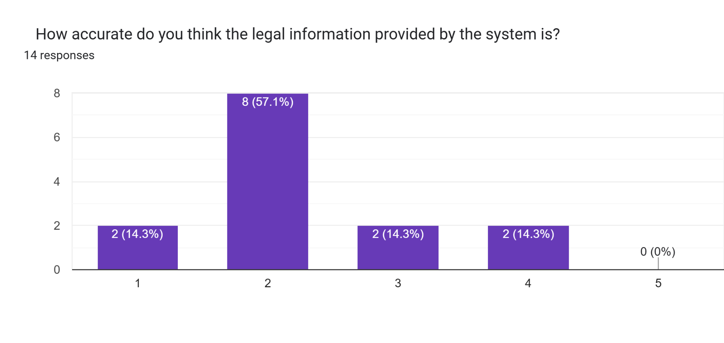

5.5.6 Feature Evaluation
Participants were asked which features of the MUFASHE system they found most helpful.
The results show that:
- AI Legal Question Answering was selected by 93.3%
- Lawyer Booking was selected by 73.3%
- Legal Document Library was selected by 66.7%
- Lawyer Directory was selected by 6.7%
These results indicate that the AI consultation feature is the most valuable component of the system.
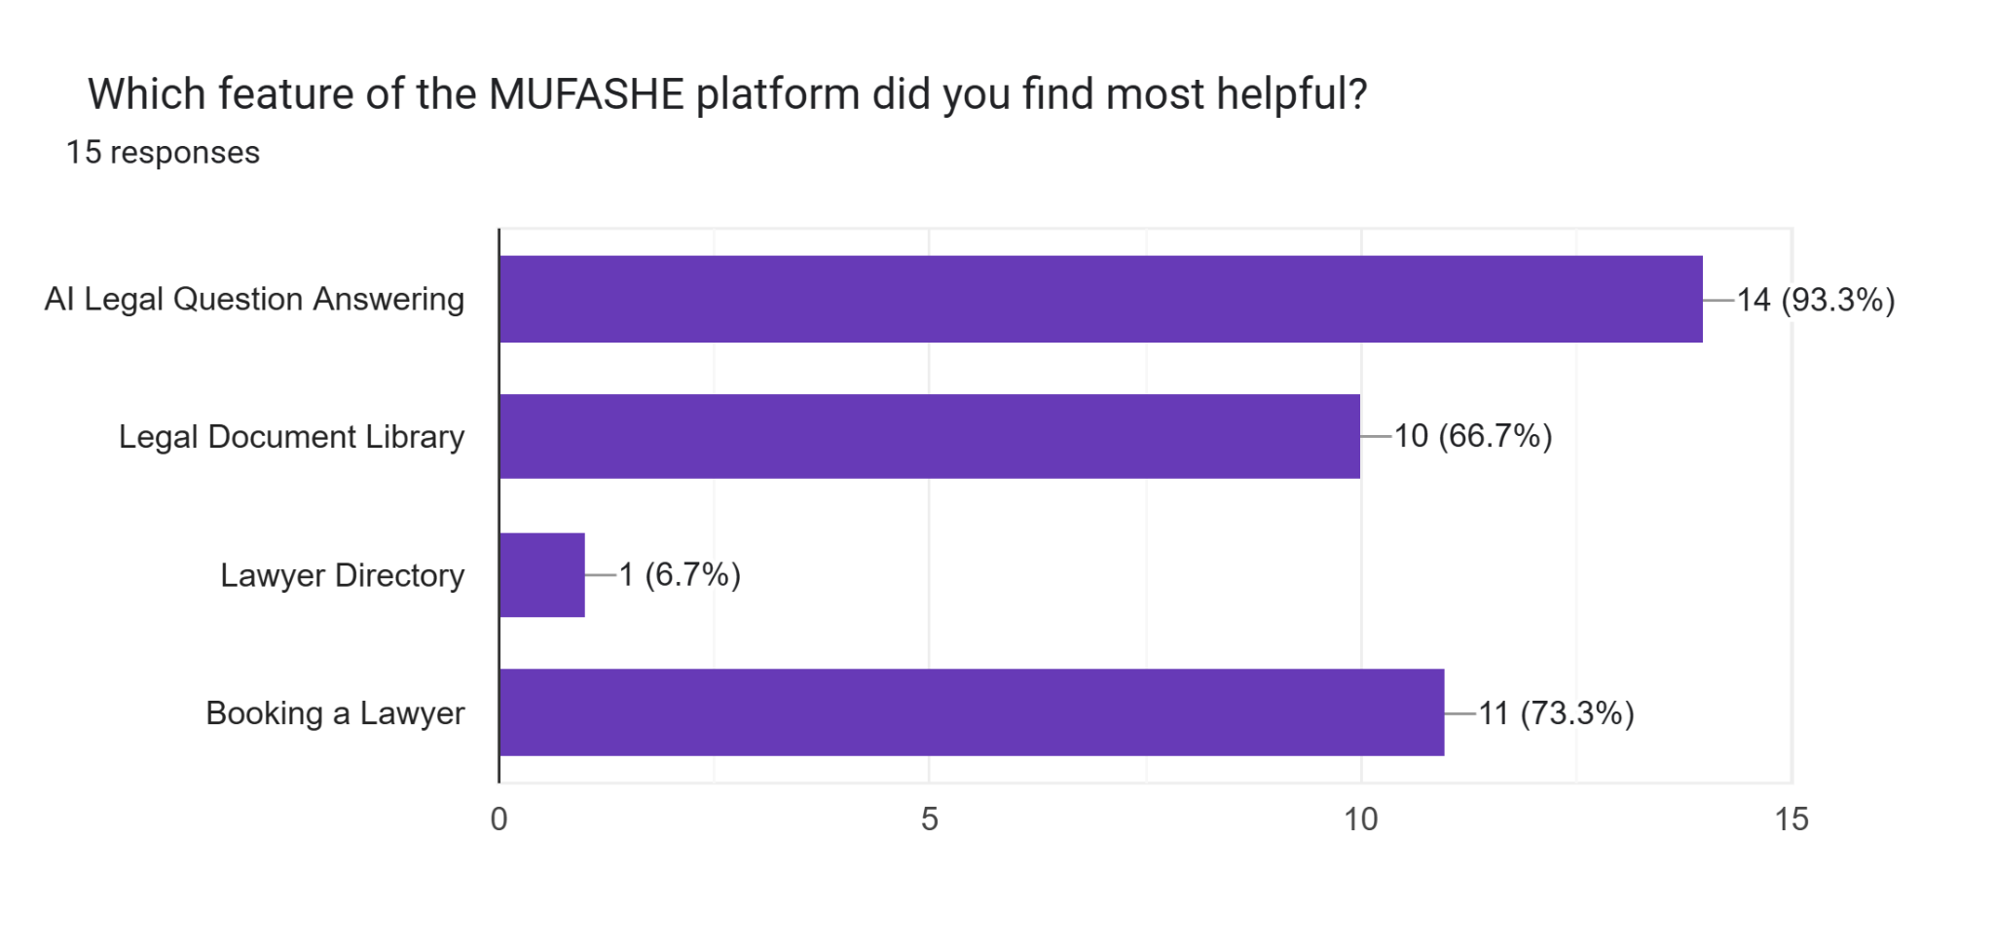

5.5.7 System Recommendation
Participants were asked whether they would recommend the MUFASHE system to other users.
The results show that 100% of respondents indicated that they would recommend the application.
This demonstrates a high level of satisfaction and confidence in the system.
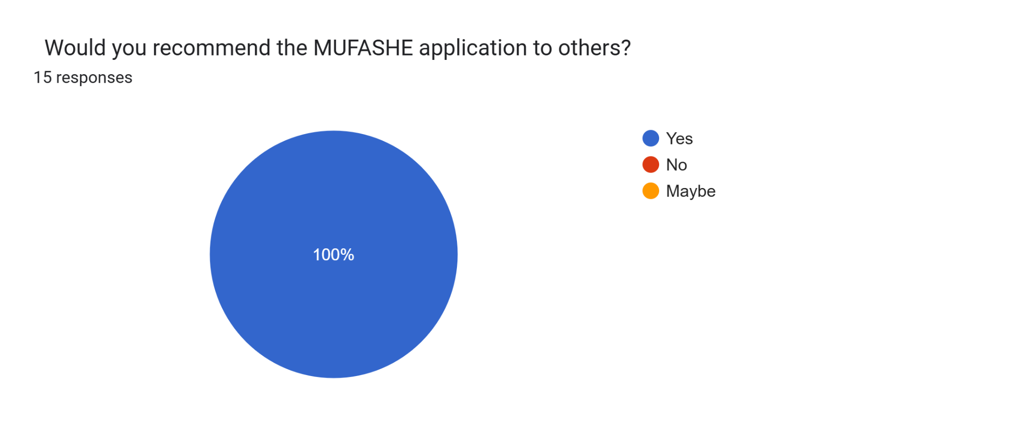
This chart shows that most users are willing to use MUFASHE again in the future. Out of 15 respondents, 60% said they are likely to use it again, 26.7% said they are very likely, and 13.3% were neutral. No one selected unlikely or very unlikely. This means the system was well accepted and users found it useful for accessing legal information.

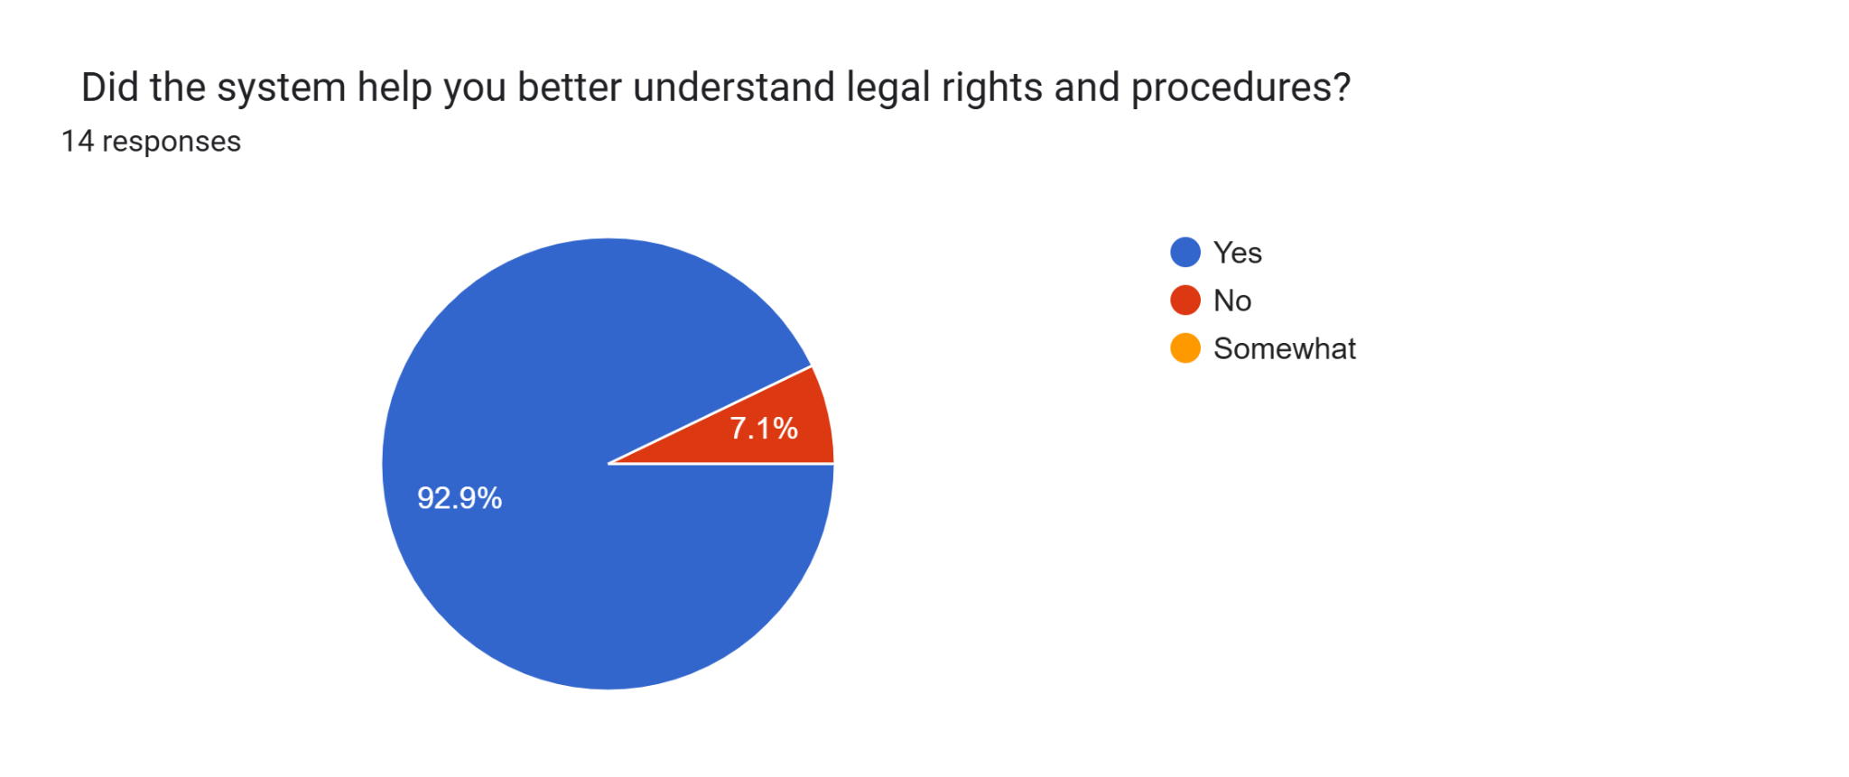

5.6 Evaluation of System Objectives
The results obtained from implementation and testing indicate that the MUFASHE platform successfully achieved the main objectives of the study.
The first objective was to develop an AI-powered mobile system that allows users to submit legal questions and receive legal guidance. This objective was achieved through the consult feature and AI-based legal explanation system.
The second objective was to implement a legal document processing pipeline that converts legal texts into searchable embeddings. This was successfully implemented through the document chunking and vector embedding system used for similarity search.
The third objective was to provide simplified explanations of legal concepts that are understandable to non-lawyers. The AI legal assistant generates simplified responses that help users better understand legal issues.
The fourth objective was to evaluate the usability and effectiveness of the platform. The user survey results show that most participants found the system useful and indicated that they would recommend it to others.
These findings demonstrate that the MUFASHE system effectively supports legal awareness and improves access to legal information.
5.7 Discussion of Results
The results obtained from both system testing and user evaluation indicate that the MUFASHE platform successfully provides legal guidance through an AI-powered mobile application.
The system demonstrated strong performance in retrieving relevant legal information and generating explanations based on verified legal documents. User evaluation results also indicate that the platform improves users' understanding of legal issues and provides a convenient way to access legal information.
However, the results also highlight areas where the system can be improved. In particular, expanding the legal dataset and improving the AI model could increase the accuracy of legal explanations. Additional language support and integration with more legal professionals could further strengthen the platform.
Overall, the findings show that MUFASHE has strong potential to contribute to improving legal awareness and supporting access to justice.

5.8 Chapter Summary
This chapter presented the results obtained from the implementation and evaluation of the MUFASHE platform. The evaluation included both system performance testing and user feedback collected through a survey.
The results show that the system successfully supports users in accessing legal information through an AI-powered mobile application. Users were able to submit legal questions, receive simplified explanations, browse legal documents, and connect with legal professionals when needed.
The user survey results also indicate that the system is useful, easy to use, and recommended by most participants. Overall, the findings demonstrate that the MUFASHE platform has strong potential to improve legal awareness and make legal guidance more accessible to the public.

CHAPTER 6: CONCLUSIONS AND RECOMMENDATIONS

6.1 Conclusion
This study focused on the design and development of the MUFASHE platform, an AI-powered mobile system designed to improve access to legal information and legal guidance for citizens. The project addressed the challenge that many individuals face when trying to understand legal procedures, laws, and their rights. In many situations, legal texts are complex and professional legal services may not always be easily accessible. As a result, ordinary citizens may experience confusion or fear when facing legal matters.
The results presented in the previous chapters demonstrate that the MUFASHE system was successfully implemented and tested. The mobile application allows users to submit legal questions through a simple interface and receive explanations generated using relevant legal documents stored in the system. By applying technologies such as vector embeddings and similarity search, the platform can retrieve the most relevant legal information before generating responses. This approach helps ensure that answers are based on real legal sources rather than purely generated content.
In addition, the platform includes other useful components such as a legal document library, lawyer directory, and appointment booking system. These features allow users not only to obtain simplified legal explanations but also to explore legal resources and connect with legal professionals when necessary. The system therefore provides both informational and practical support for users facing legal questions.
The development of this system was also influenced by real-life experiences where a lack of legal awareness can lead to misunderstandings, financial loss, or unnecessary fear when interacting with authorities. Situations such as purchasing goods without knowing the legal consequences can place individuals in vulnerable positions when they do not clearly understand their rights. A system like MUFASHE can help reduce such situations by providing accessible legal guidance that empowers citizens to make more informed decisions.
Overall, the results of the project demonstrate that combining mobile technology, artificial intelligence, and structured legal knowledge can create an effective tool for improving legal awareness and supporting access to justice. The MUFASHE platform therefore represents a promising step toward making legal information more accessible, understandable, and practical for everyday users.

6.2 Recommendations
Although the MUFASHE platform successfully achieved its primary objectives, several improvements could further strengthen the system and increase its impact.
One important recommendation is the integration of real licensed lawyers and legal institutions into the platform. While the current system includes a lawyer directory and booking feature, future versions of the system could collaborate with practicing lawyers, law firms, and legal aid organizations. Verified lawyers could create professional profiles that include their specialization, consultation fees, availability, and professional credentials. This would allow users who receive legal guidance from the AI system to directly schedule consultations with qualified legal professionals when deeper legal advice is needed.
Another recommendation is the expansion of the legal document knowledge base used by the system. For example, including additional legislation, court decisions, legal guidelines, and policy documents would allow the platform to answer a wider range of legal questions. A larger legal dataset would improve the system’s ability to provide more comprehensive legal guidance.
In addition, improving the natural language processing capabilities of the system could enhance the accuracy and clarity of AI-generated responses. More advanced language models may allow the system to better understand complex user queries and produce clearer explanations of legal concepts.
It is also recommended that the system expand its language accessibility, particularly by improving support for local languages such as Kinyarwanda. Providing high-quality multilingual explanations would allow the platform to reach a broader population and make legal information easier to understand for users who are more comfortable in their native language.
Finally, future development could include additional communication features, such as in-app messaging or virtual consultations with lawyers. These features would transform the platform into a more complete legal assistance ecosystem where users can receive both automated legal guidance and direct professional support.

6.3 Limitations of the Study
Despite the positive outcomes of the project, several limitations should be acknowledged.
One limitation relates to the scope of the legal dataset used in the system. The AI retrieval system depends on the legal documents stored in the knowledge base. If certain legal topics are not included in the dataset, the system may not be able to provide detailed answers for those areas.
Another limitation concerns the testing environment used during the development process. The system was primarily tested within a controlled development setting rather than through large-scale public deployment. Therefore, the evaluation results mainly reflect controlled testing conditions rather than long-term real-world usage across diverse user populations.
In addition, while artificial intelligence can assist in retrieving and explaining legal information, it cannot completely replace professional legal advice. Legal matters often require detailed case-specific analysis by trained legal professionals. For this reason, the MUFASHE system should be considered a support tool that helps users better understand legal concepts rather than a substitute for qualified lawyers.

6.4 Suggestions for Future Research
Future research could extend this work in several important directions.
One potential area for further study is the development of more advanced AI models capable of deeper legal reasoning. Such models could improve the system’s ability to handle complex legal scenarios that involve multiple laws or legal interpretations.
Another direction involves expanding the platform to support multiple languages and regional legal contexts. Research could explore how AI-based legal assistance systems can be adapted for different countries or legal systems while still maintaining accuracy and reliability.
Researchers could also investigate how digital legal guidance platforms such as MUFASHE can be integrated with government justice systems or legal aid programs. For example, users could receive automated legal explanations and then be connected directly to official institutions for further support.
Finally, future studies could involve large-scale user evaluations involving citizens, lawyers, and justice sector stakeholders. Such evaluations would provide deeper insights into how users interact with the system and how AI-powered legal assistance tools can be improved for real-world deployment.

References
1. AllAfrica. (2025, June 8). Rwanda’s overall household internet usage reaches 30%. https://allafrica.com/stories/202506100022.html
2. Anu. (2025). The role of artificial intelligence in transforming legal practice and access to justice. Indian Journal of Law, 3(4), 27–30. https://doi.org/10.36676/ijl.v3.i4.113
3. AST Consulting. (2025). Cross platform app development using React Native. https://astconsulting.in/app-development/cross-platform-app-react-native-5
4. Bacancy Technology. (2025). Why use React Native for mobile apps. https://www.bacancytechnology.com/blog/why-use-react-native
5. Borgesano, F., De Maio, A., Laghi, P., & Musmanno, R. (2025). Artificial intelligence and justice: A systematic literature review. Journal of E Justice Innovation.
6. Chaudhary, S. (2026). Digital pathways to justice: Leveraging AI and LegalTech for underprivileged communities. Lex Localis–Journal of Local Self-Government, 22(S1), 94–115. https://www.researchgate.net/publication/399603777
7. DataReportal. (2026). Digital 2026: Rwanda. https://datareportal.com/reports/digital-2026-rwanda
8. E Sutra Technologies. (2025). The benefits of using cloud based services in app development. https://e-sutra.com/blog/the-benefits-of-using-cloud-based-services-in-react-native-app-development
9. Ghoshal, R. (2025). Cross border AI governance for legal tech: Standardizing ethical and legal norms in access to justice. International Journal of Law, Justice and Jurisprudence, 5(1), 186–194. https://doi.org/10.22271/2790-0673.2025.v5.i1c.177
10. Han, X., Li, Y., Zhang, Z., & Liu, Q. (2024). Artificial intelligence applications in legal information systems. Journal of Legal Technology, 18(2), 45–60.
11. Kalaycioglu, S., Liu, B., Hong, C., & Xie, H. (2025). AI powered legal intelligence system architecture: A comprehensive framework for automated legal consultation and analysis. arXiv. https://arxiv.org/abs/2508.17499
12. Legal Aid Forum. (2020). Legal awareness study in Rwanda. Kigali, Rwanda: Legal Aid Forum.
13. Magesh, V. M., Surani, F., Dahl, M., Suzgun, M., Manning, C. D., & Ho, D. E. (2024). Hallucination free? Assessing the reliability of leading AI legal research tools. arXiv. https://arxiv.org/abs/2405.20362
14. MoldStud. (2025). Top 10 advantages of Node.js for mobile app development. https://moldstud.com/articles/p-top-10-reasons-to-choose-nodejs-for-your-mobile-apps-boost-performance-and-scalability
15. Mowbray, C., Chung, D., & Greenleaf, G. (2021). Utilising AI in the legal assistance sector—Testing a role for Legal Information Institutes. Information & Communications Technology Law, 30(2), 123–140.
16. Nuwamanya, E. (2022, November 25). Rwanda launches laws web portal. KT Press. https://www.ktpress.rw/2022/11/rwanda-launches-laws-web-portal/
17. Organisation for Economic Co-operation and Development. (2025). AI in justice administration and access to justice. OECD Publishing. https://www.oecd.org/en/publications/governing-with-artificial-intelligence_795de142-en/full-report/ai-in-justice-administration-and-access-to-justice_f0cbe651.html?.com
18. Rwanda Ministry of Justice. (2022, November 16). Rwanda launches laws web portal. KT Press. https://www.ktpress.rw/2022/11/rwanda-launches-laws-web-portal
19. Saadany, H., Orăsan, C., Breslin, C., Barczentewicz, M., & Walker, S. (2025). Employing AI for better access to justice: An automatic text to video linking tool for UK Supreme Court hearings. Applied Sciences, 15(16), 9205. https://doi.org/10.3390/app15169205
20. Statistics gov Rwanda. (2023). Education characteristics of population (literacy rates). https://statistics.gov.rw/sites/default/files/documents/2025-02/Education.pdf
21. Statistics gov Rwanda. (2025). Education and literacy statistics. https://statistics.gov.rw/statistical-publications/primary-secondary-and-literacy?.com
22. Statistics gov Rwanda. (2025). Population size and characteristics. https://www.statistics.gov.rw/statistical-publications/population-size-and-population-characteristics
23. Tan, J., & Benyekhlef, K. (2025). LegalWebAgent: Empowering access to justice via LLM based web agents. arXiv. https://arxiv.org/abs/2512.04105
24. United Nations. (2024). The rule of law at the national and international levels (A/79/226). United Nations.
25. United Nations Development Programme. (2021). Global access to justice report 2021. New York, NY: UNDP.
26. Watanabe, A. (2024). Artificial intelligence and access to justice: Technology’s role in legal systems from a human rights perspective. International Scientific Conference on AI, Human Rights, Migration, Democracy, and Public Impact. https://www.researchgate.net/publication/395638561

